**PHILANTHROPY: JOURNAL OF PSYCHOLOGY**FAKULTAS PSIKOLOGI 

UNIVERSITAS SEMARANG

Jl. SoekarnoHattaTlogosari Semarang 50196 ;Surel: filantropi@usm.ac.id

**AUTHORS STATEMENT OF ORIGINALITY**

To:

Editor-in-Chief

Philanthropy: Journal of Psychology

With this letter I/We declare that

Title of Article : “Religiusitasdan*Psychological Well-Being*Selama Masa PandemipadaAnggotaGerakanPemuda GPIB TamansariSalatiga”

Author(s) Name : 1. Theo DesianoWinman

2. Christiana Hari Soetjiningsih

Has been approved by the co-author/s to be published in the [Philanthropy: Journal of Psychology], does not contain plagiarism as a whole or in parts, and is not currently being submitted processed in other journals. Other things we agree on are the policy contained in the information on the website [Philanthropy: Journal of Psychology].

Salatiga, April, 4th, 2022

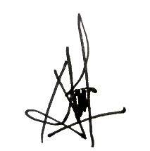**Authors Signatures**

1st Author (Full Name with Title)

Theo DesianoWinman ................................................................



2nd Author (Full Name with Title)

Christiana Hari Soetjiningsih ................................................................

**Contact person (whatsapp only) :**081226288560

*Send this signed form to **filantropi@usm.ac.id**