AUTHORS STATEMENT OF ORIGINALITY

To:
Editor-in-Chief
Philanthropy: Journal of Psychology

With this letter I/We declare that
Title of Article | : | Dinamika Interaksi Sosial terhadap Psychological Well-Being di Kalangan Mahasiswa
Author(s) Name | : | - Alia Zahra Fitriani
 |  | - Rabitha Khusna Riyantaka
 |  | - Salsabila Nashwa Aslamina

Has been approved by the co-author/s to be published in the [Philanthropy: Journal of Psychology], does not contain plagiarism as a whole or in parts, and is not currently being submitted processed in other journals. Other things we agree on are the policy contained in the information on the website [Philanthropy: Journal of Psychology].

Surabaya, October, 24, 2024

Authors |  | Signatures
1st Alia Zahra Fitriani  (aliazahra.23073@mhs.unesa.ac.id) |  | 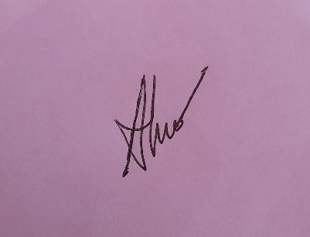
2nd Rabitha Khusna Riyantaka  (rabithakhusna.23075@mhs.unesa.ac.id) |  | 
3rd Salsabila Nashwa Aslamina (salsabilanashwa.23049@mhs.unesa.ac.id) |  | 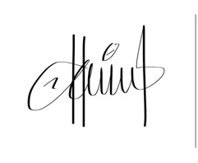

Contact person (whatsapp only) | : | 085784749566

