Mardian Putra Frans, Yudhistira Buana, Agustina Indah Intan Sa

*by* student53 uksw53

**Submission date:** 29-Apr-2024 09:21PM (UTC+0700)

**Submission ID:** 2365582591

**File name:** revisi_penulis_29-04-2024.docx (87.15K)

**Word count:** 6258

**Character count:** 41478

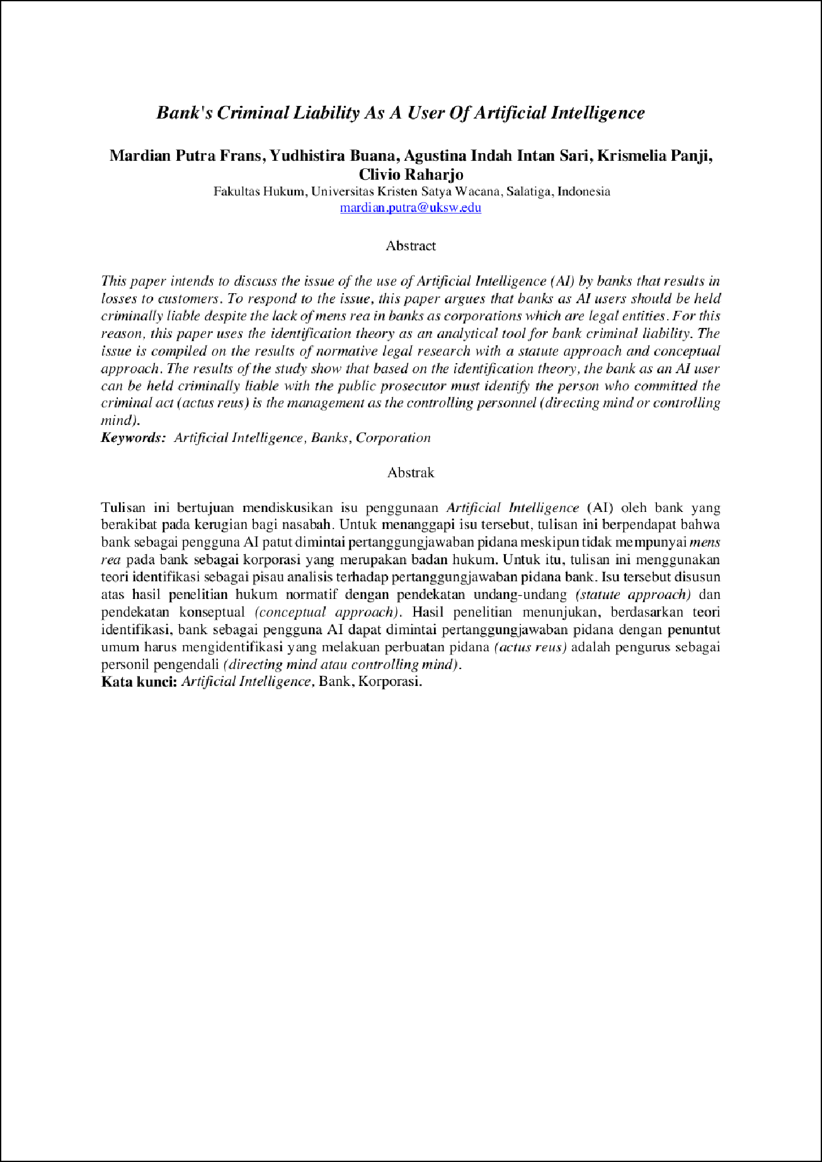

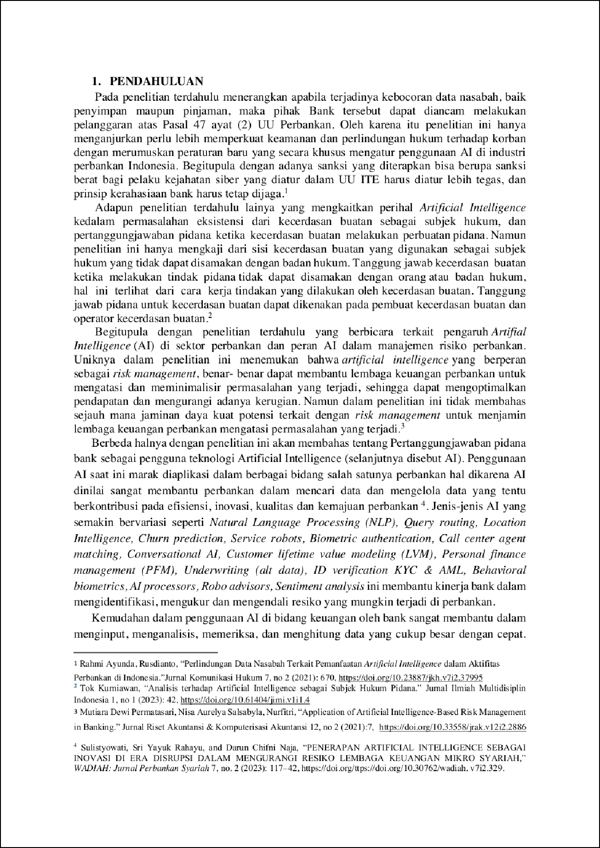

3

3

1

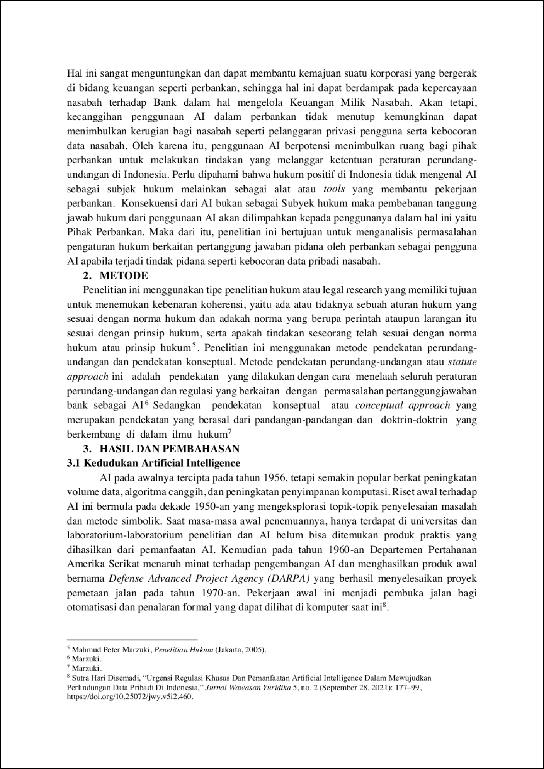

1

3

3

3

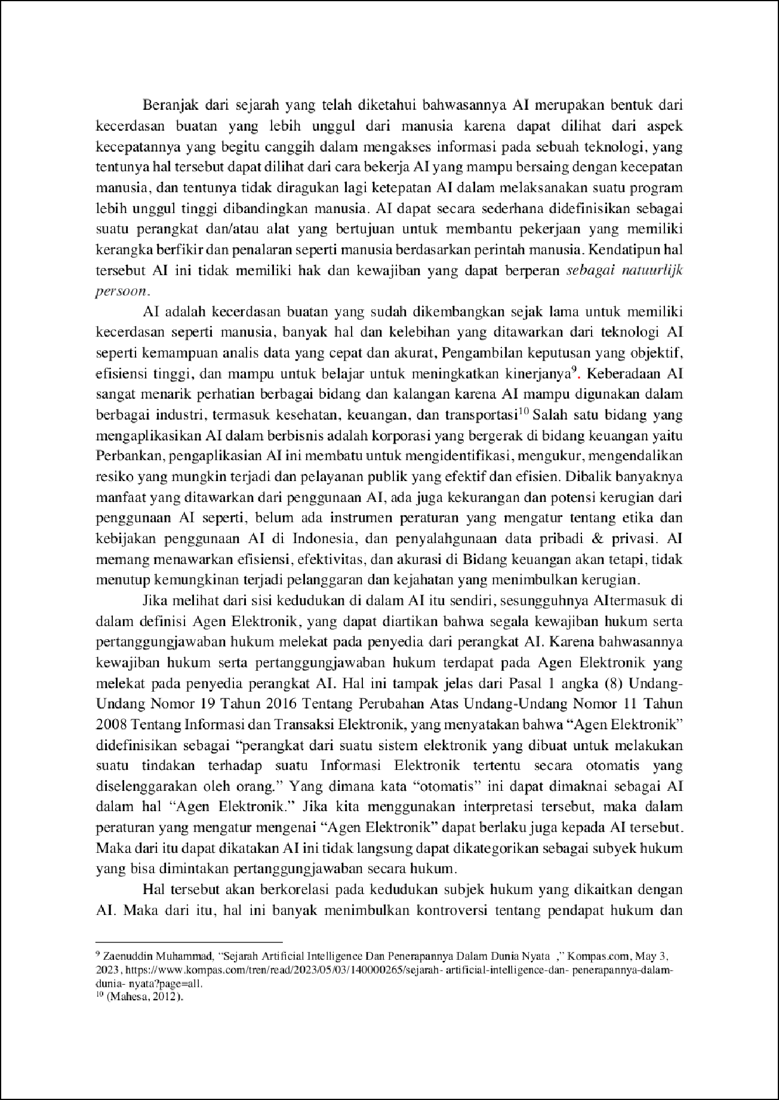

2

2

2

3

3

1

1

2

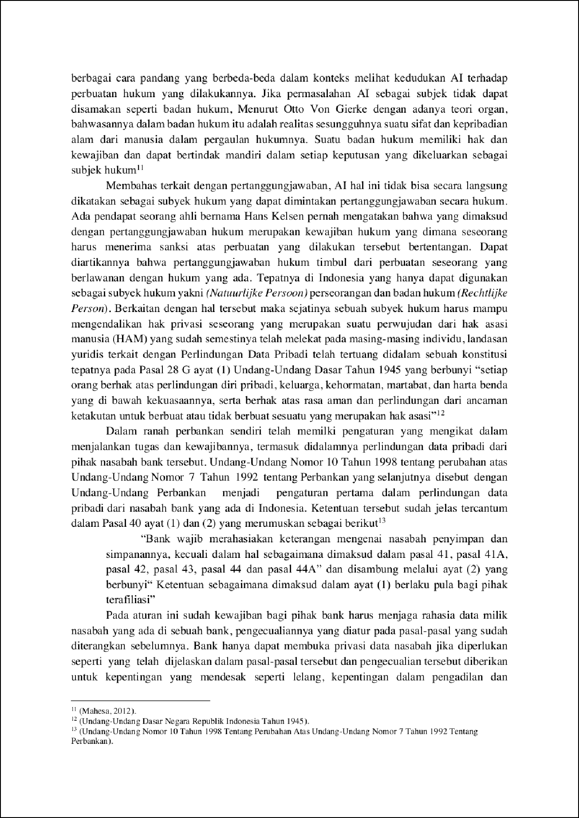

2

1

1

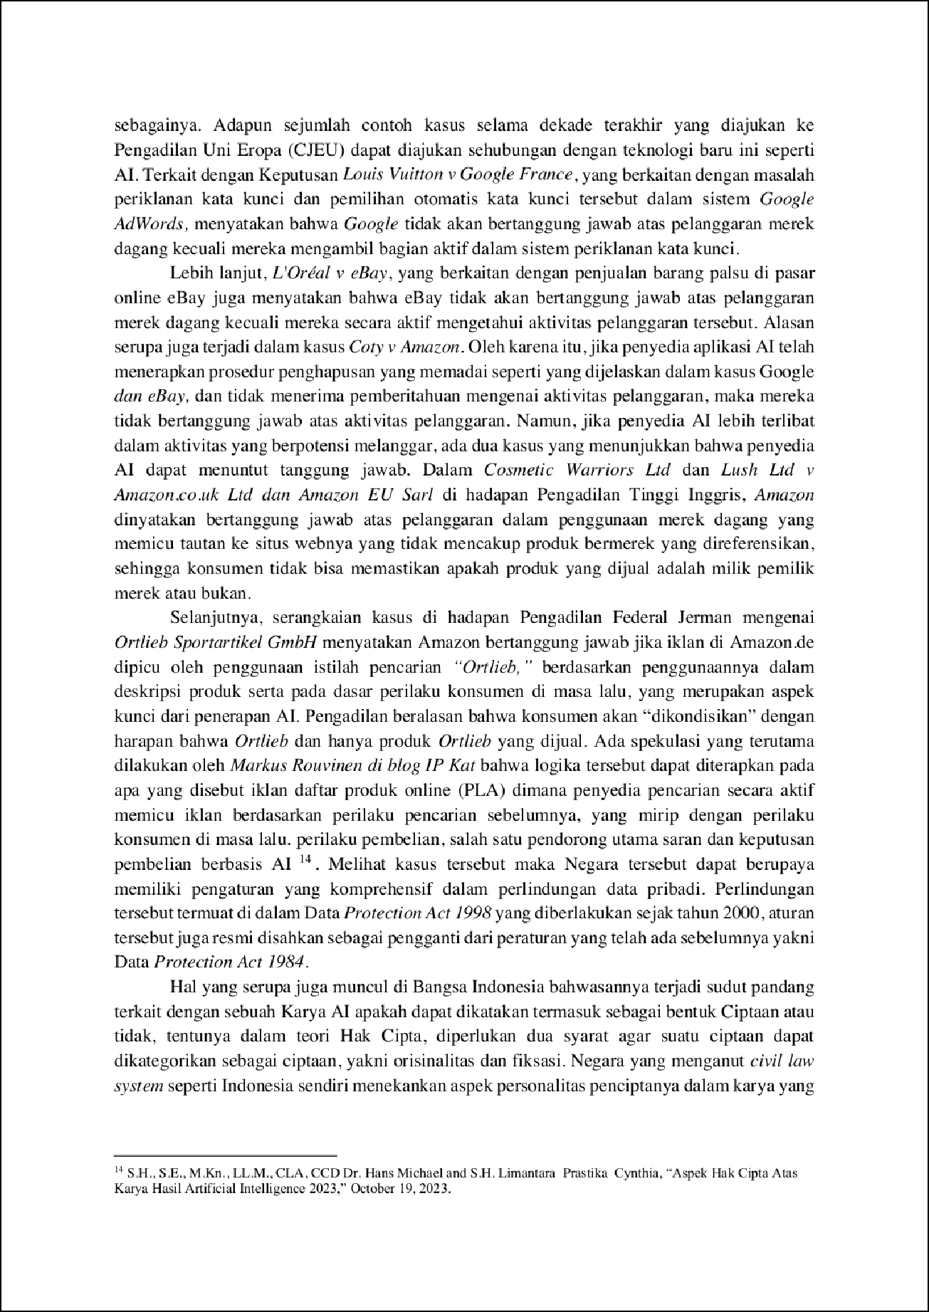

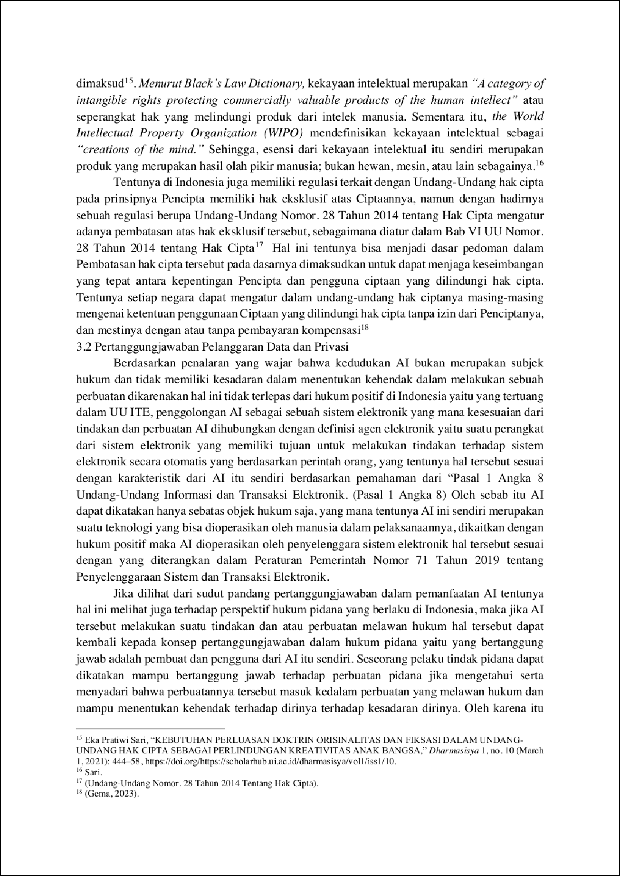

2

2

3

2

2

2

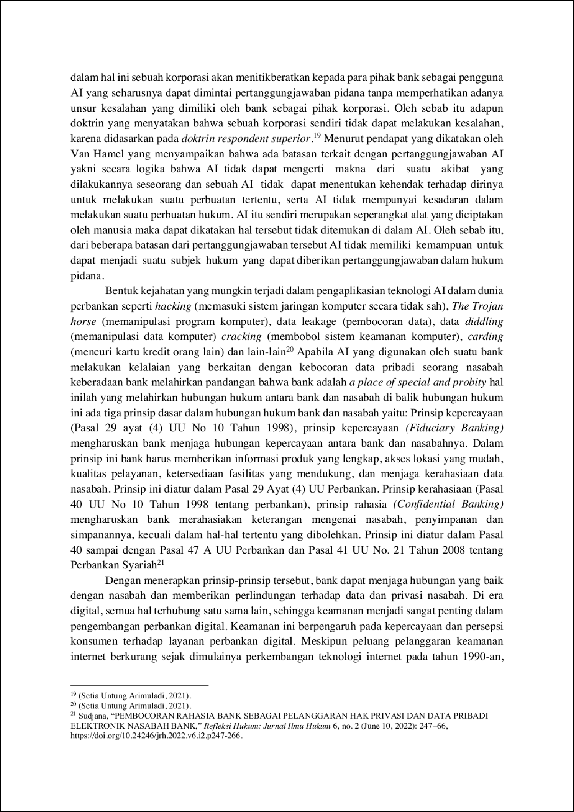

2

2

1

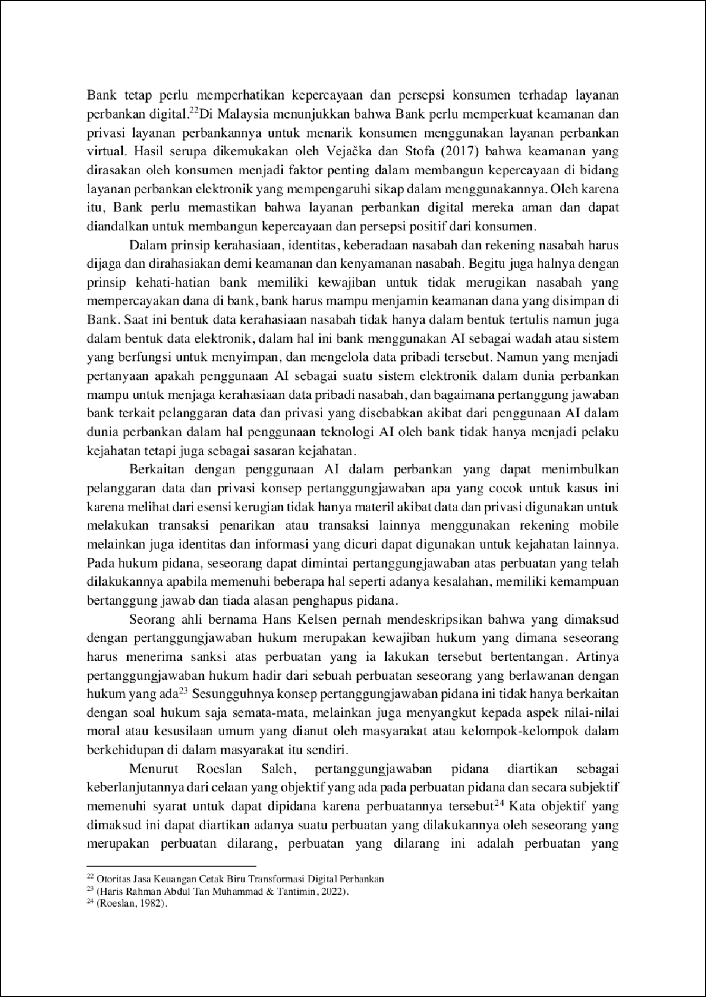

1

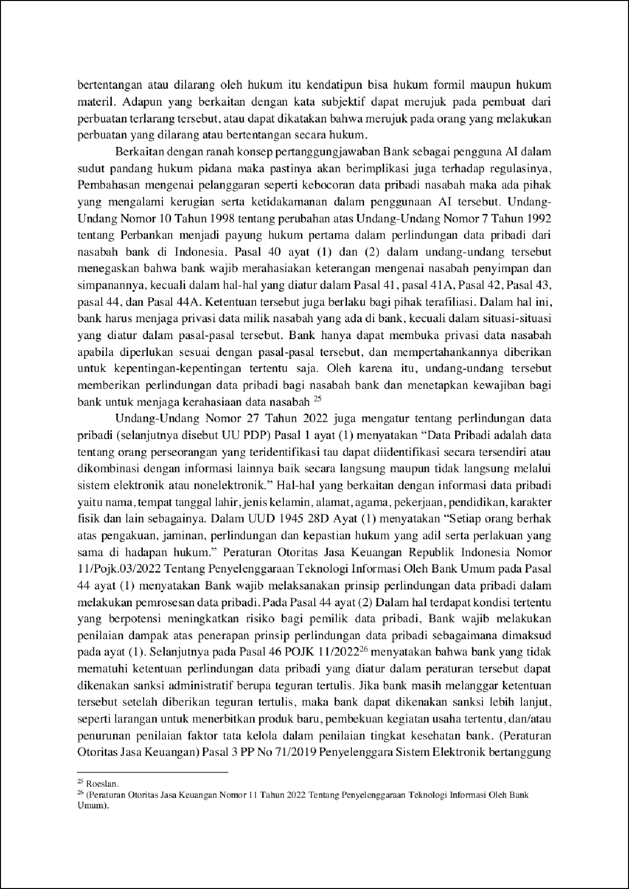

1

1

1

1

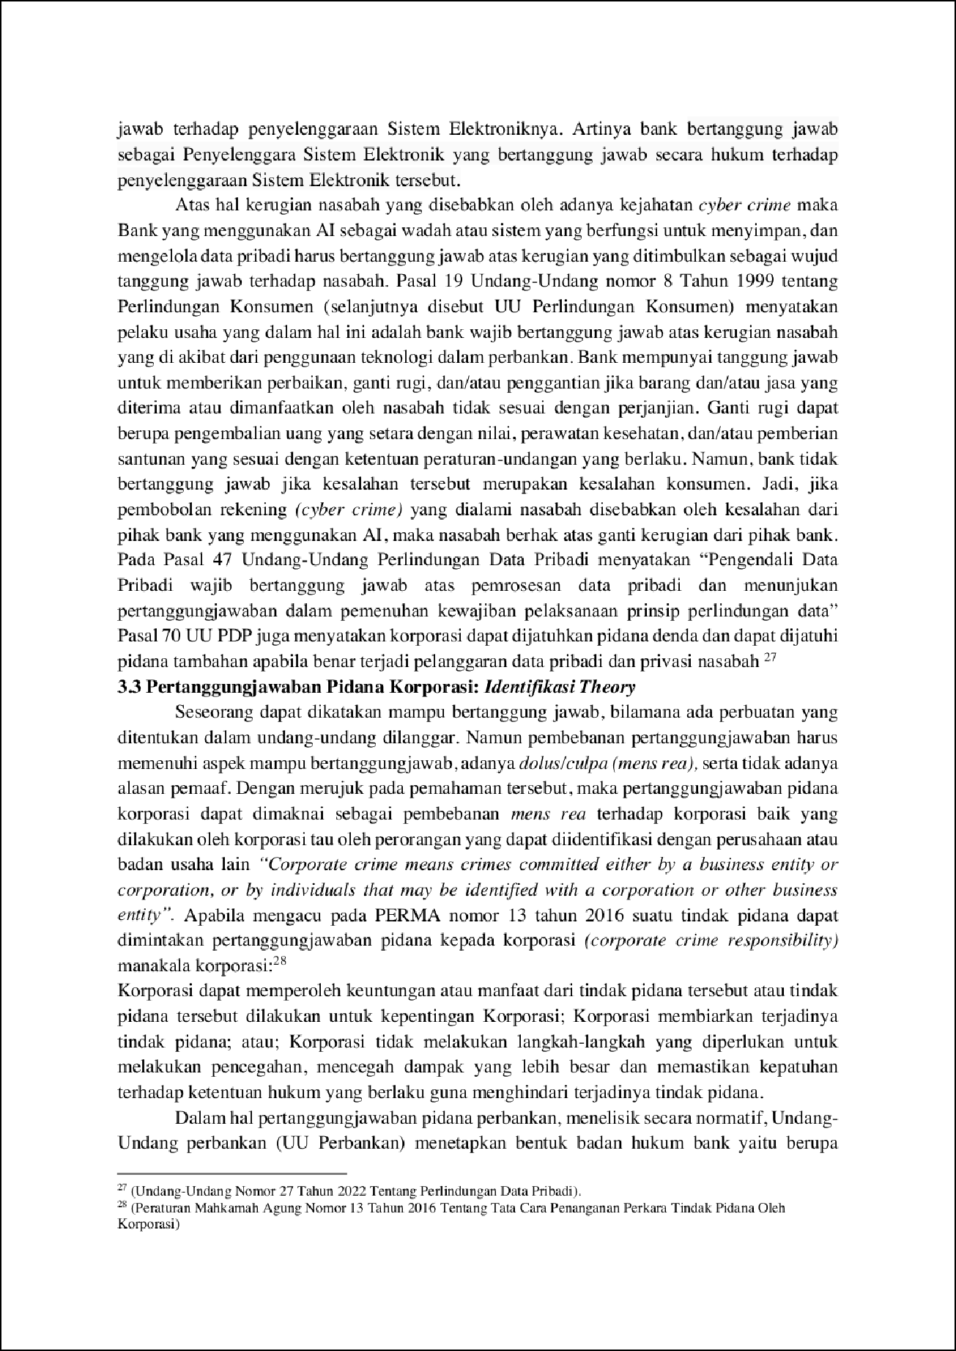

3

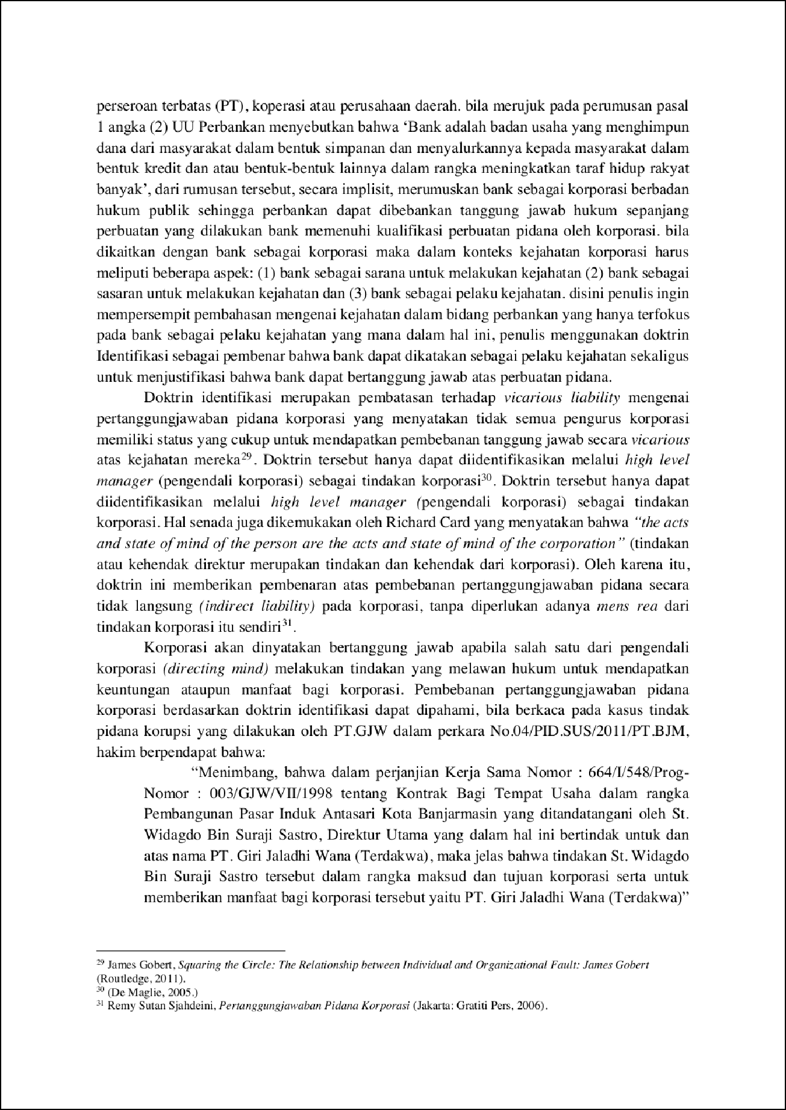

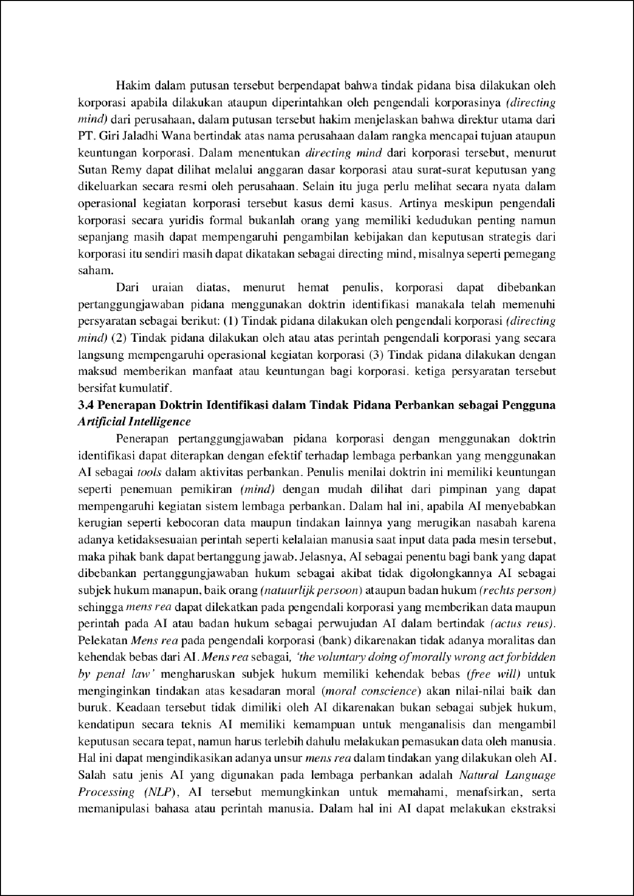

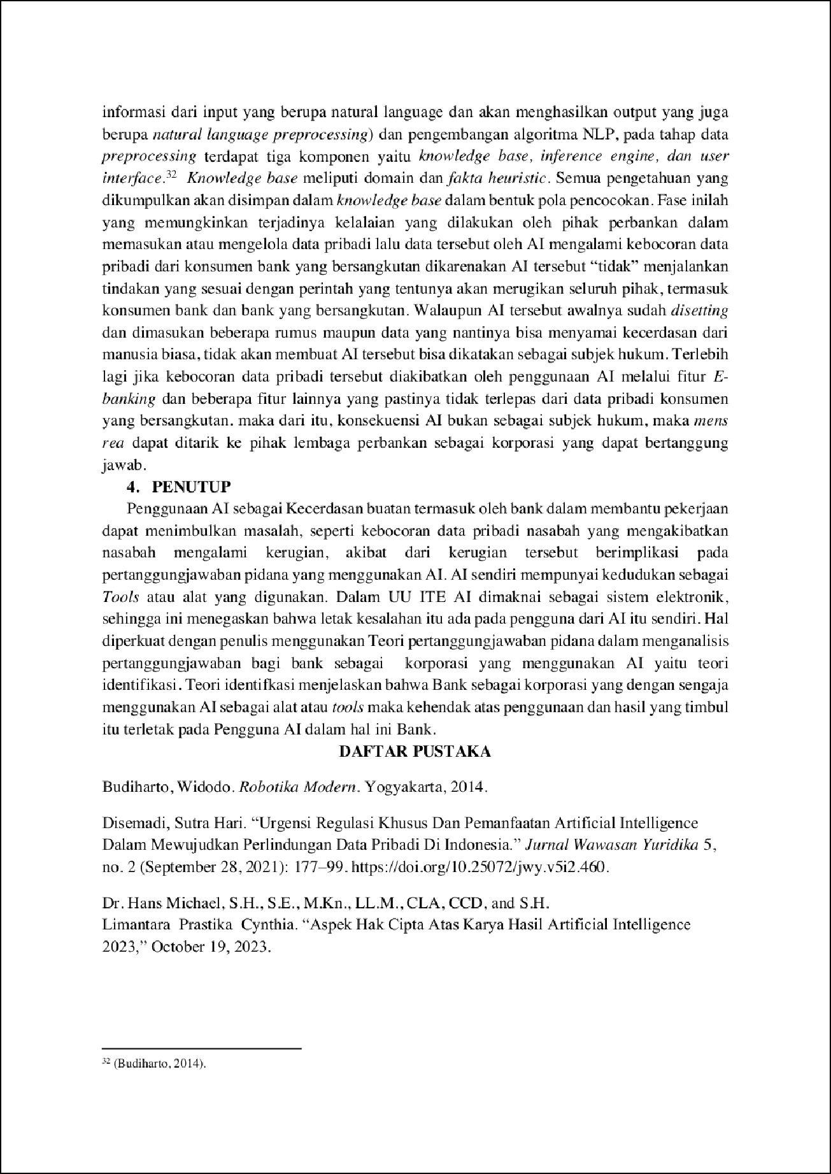

1

1

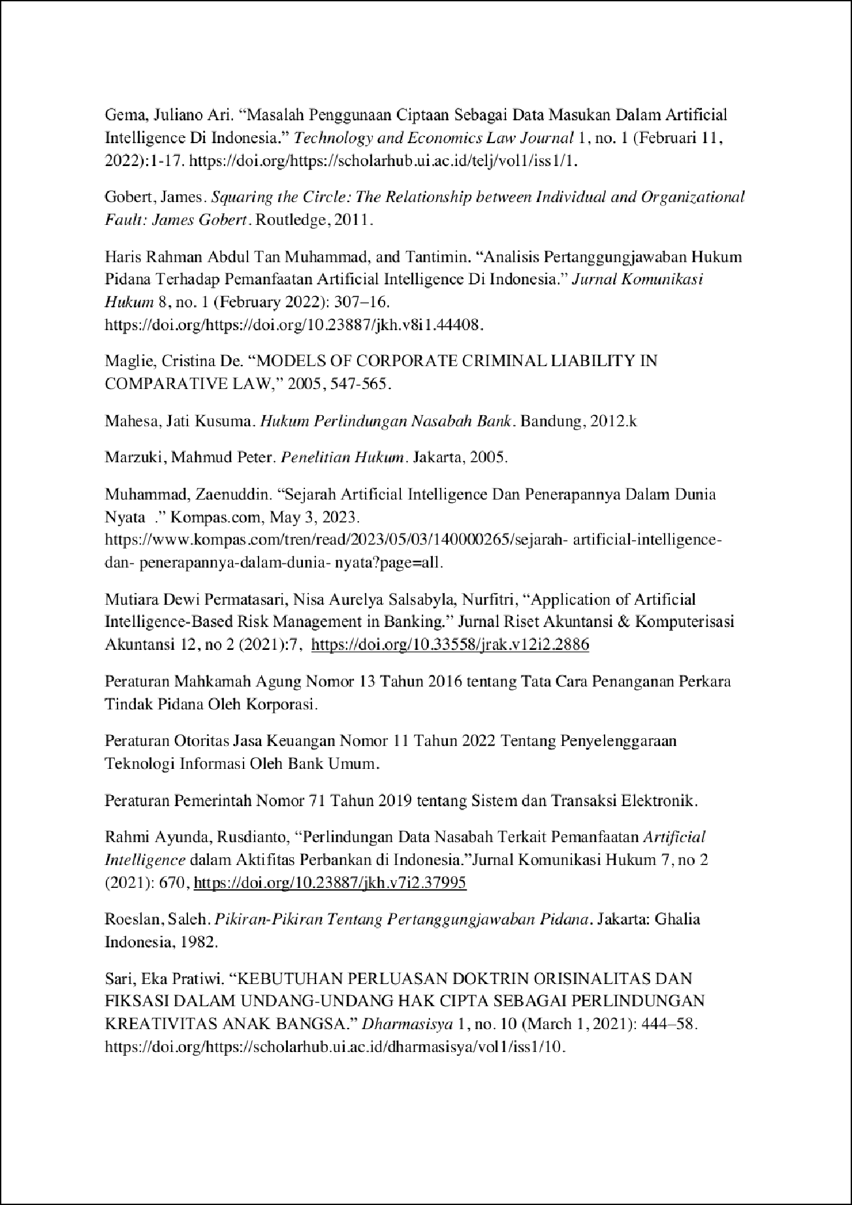

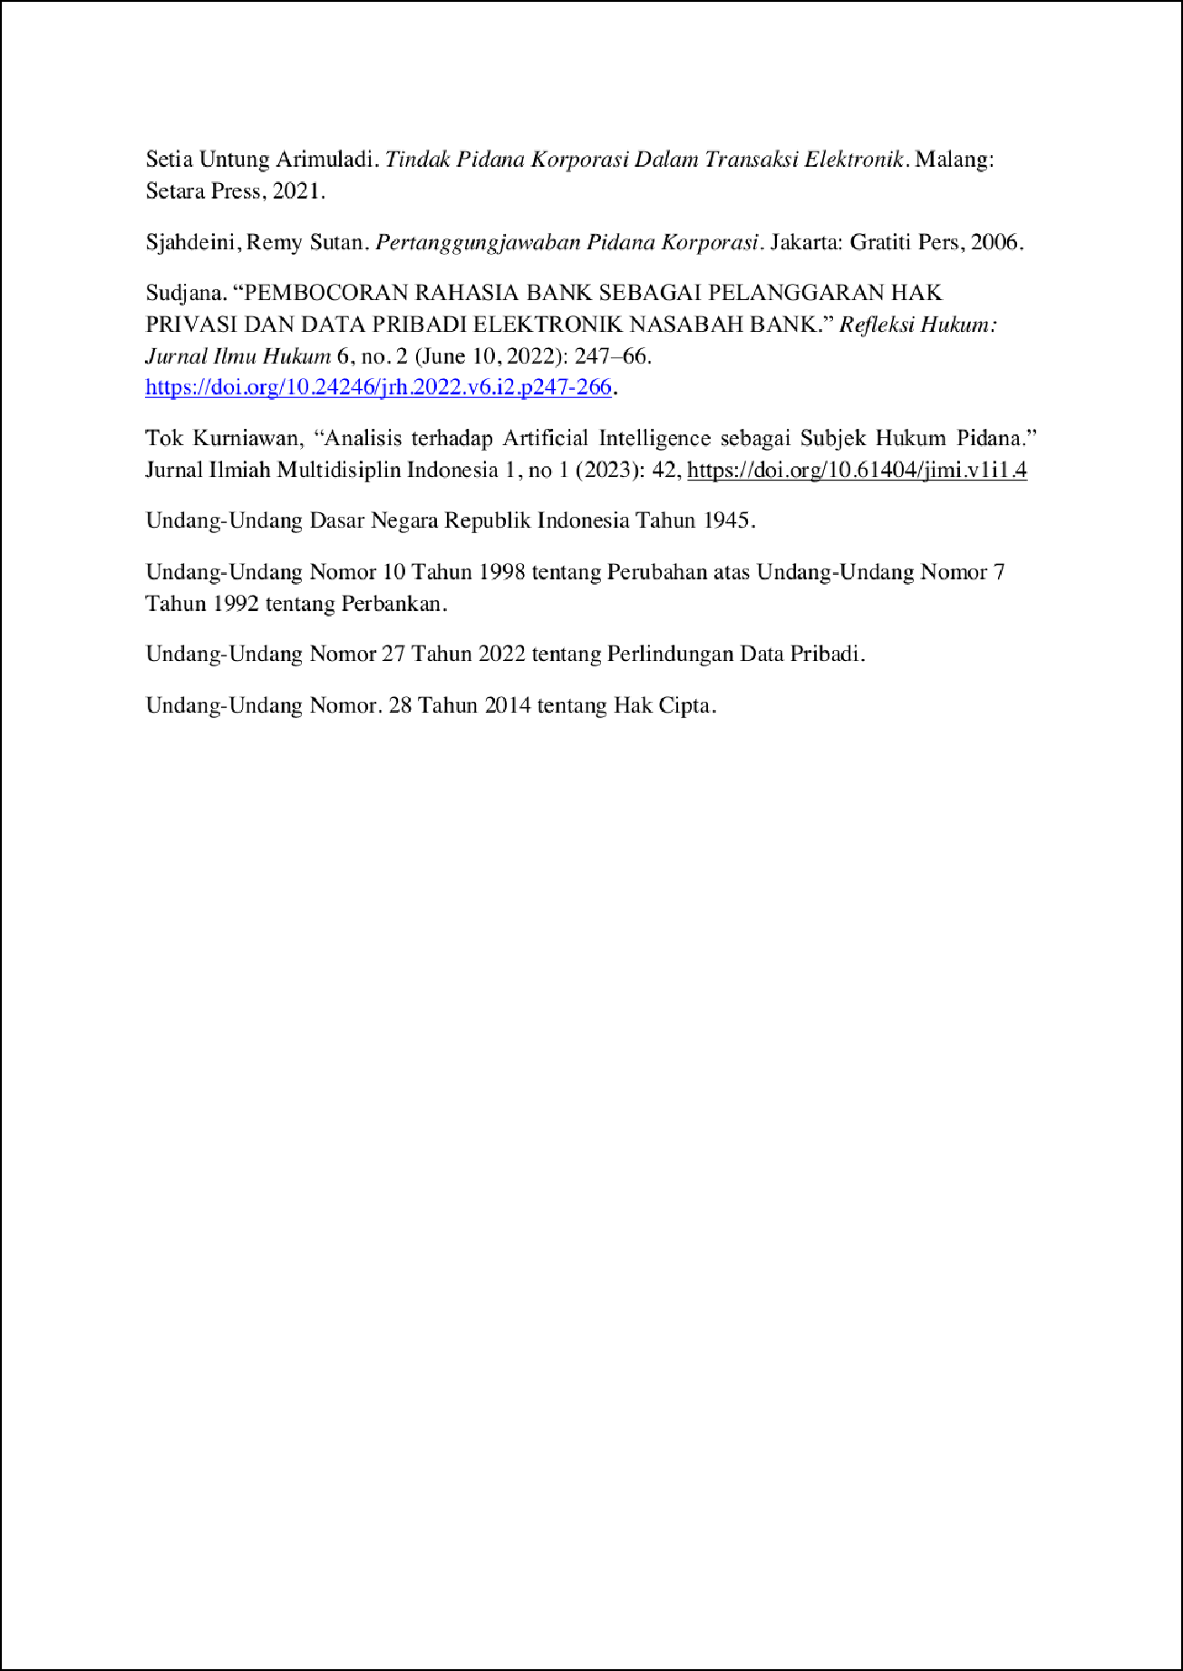

## Mardian Putra Frans, Yudhistira Buana, Agustina Indah Intan Sa

ORIGINALITY REPORT

16

## %

SIMILARITY INDEX

16%

INTERNET SOURCES

0%

PUBLICATIONS

0%

STUDENT PAPERS

PRIMARY SOURCES

# ojs.unud.ac.id

Internet Source %

1

7

6

# ejournal.undiksha.ac.id

Internet Source %

2

3

# conference.untag-sby.ac.id

Internet Source %

3

Exclude quotes On Exclude bibliography On

Exclude matches < 3%