# Perlindungan Hukum Pemberi Nama Dalam Perjanjian Pinjam Nama Terhadap Penggunaan Paylater Jika Terjadi Wanprestasi

*by* Cek Turnitin

**Submission date:** 23-Jul-2023 07:54AM (UTC-0500)

**Submission ID:** 2135324906

**File name:** turnitin_6.docx (56.51K)

**Word count:** 4799

**Character count:** 32050

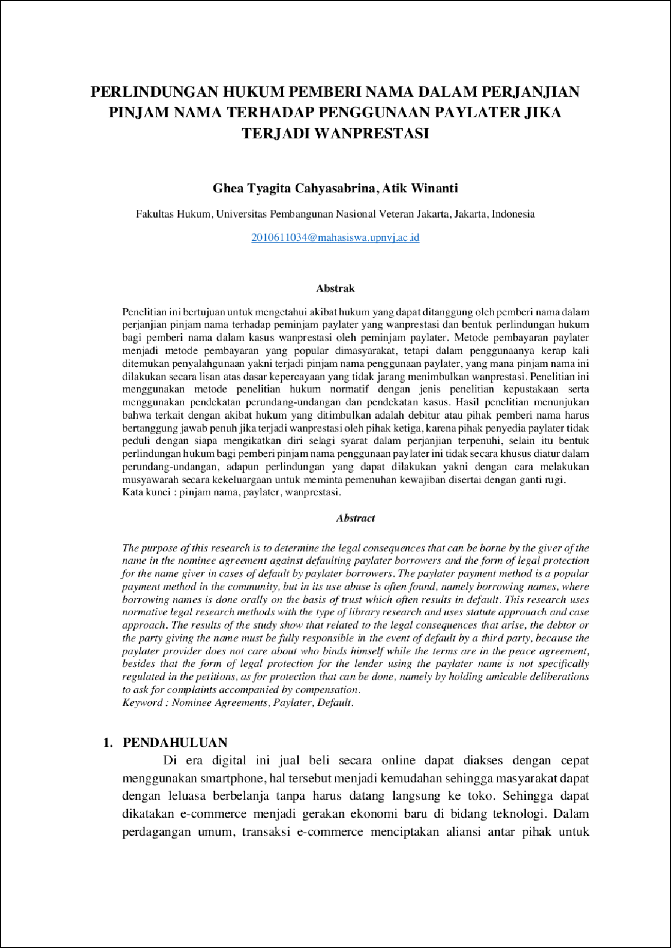

3

23

2

48

21

3

26

21

4

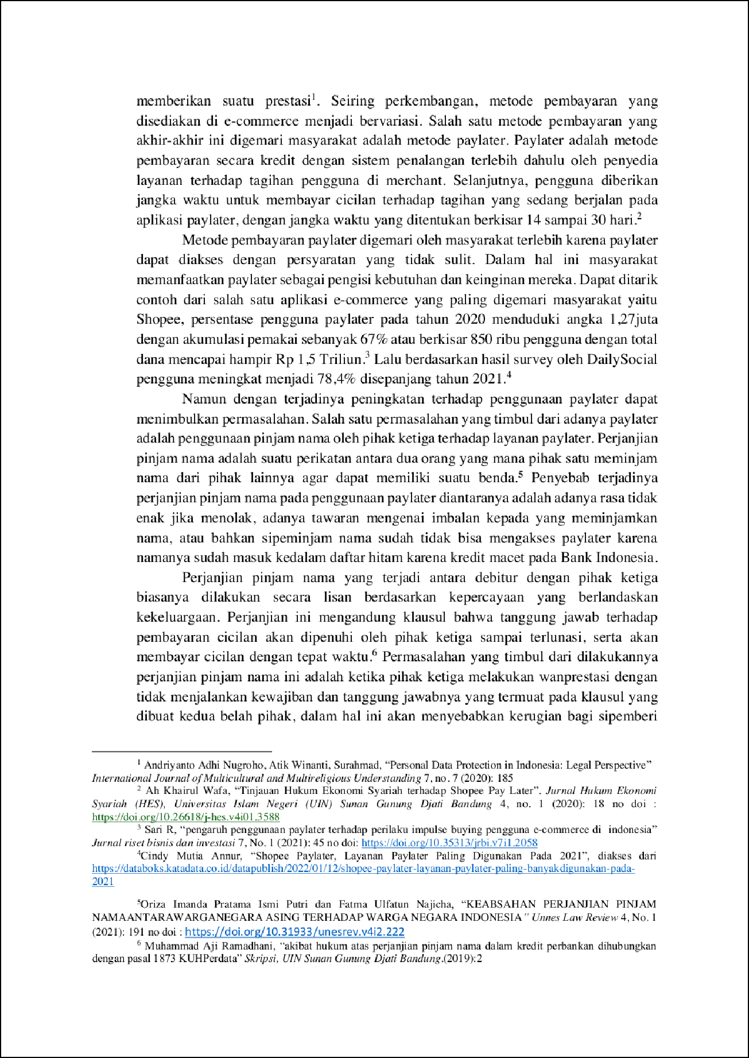

8

22

22

44

36

1

29

17

6

25

10

16

3

40

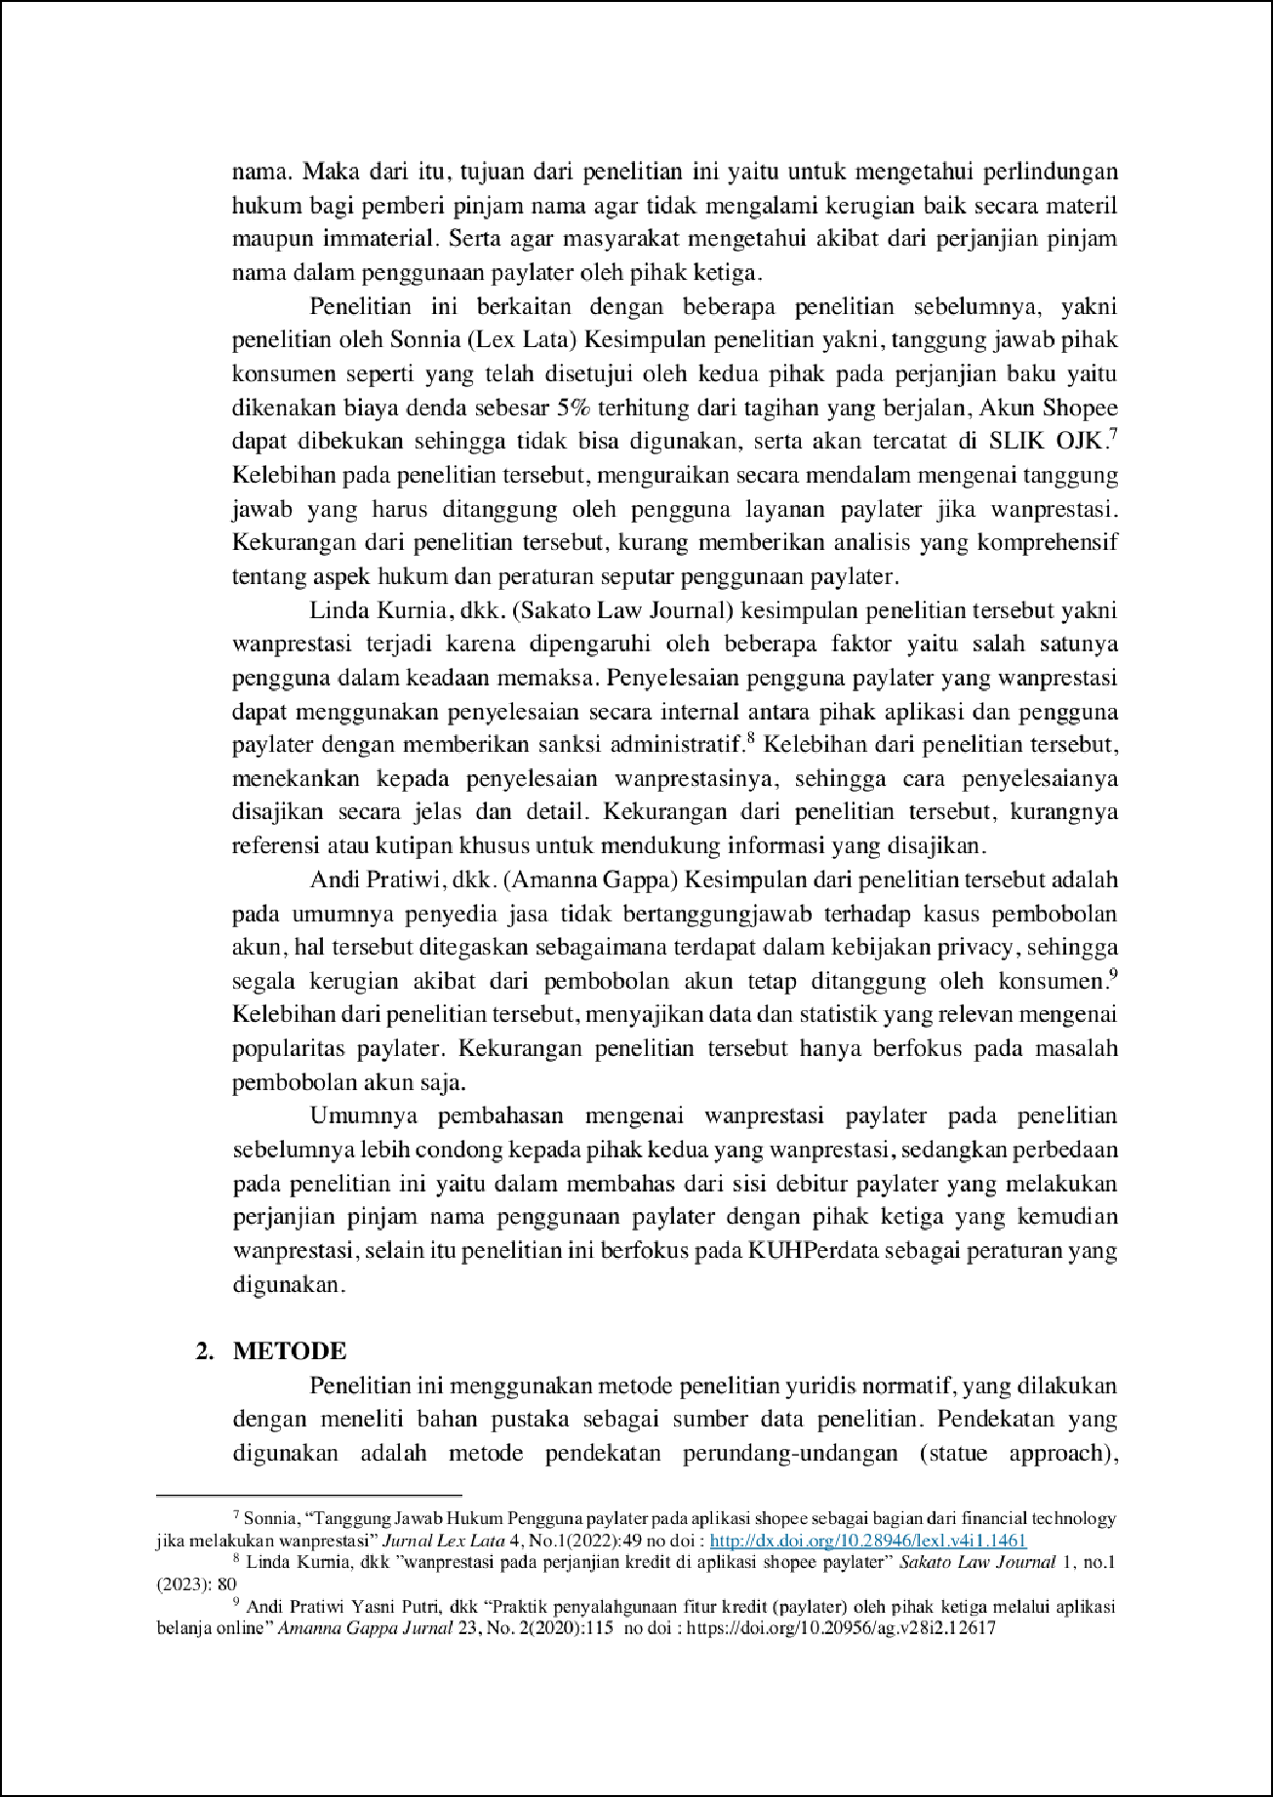

31

10

7

4

1

6

41

3

4

8

43

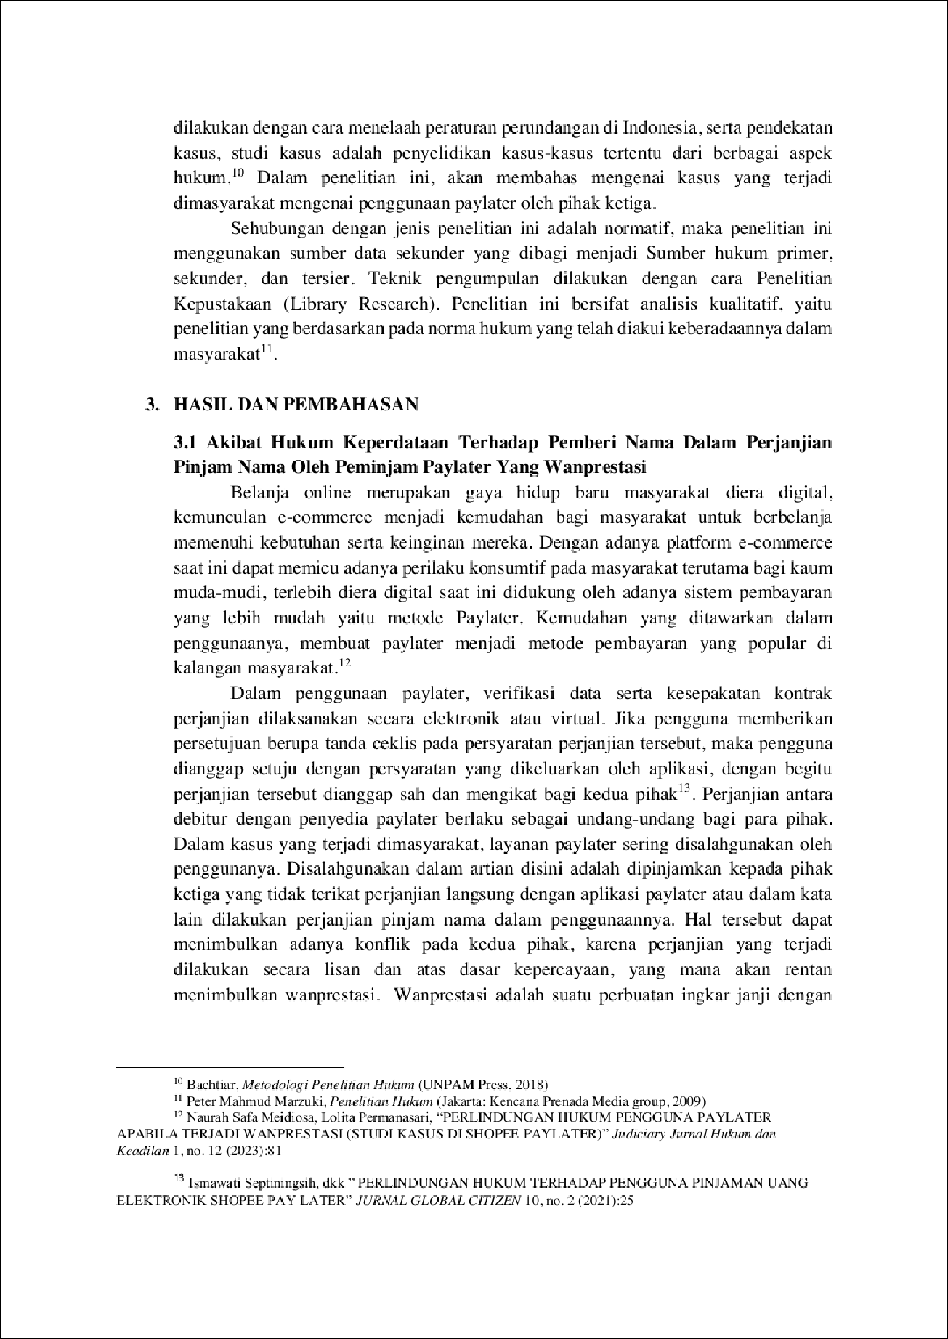

27

24

8

42

15

33

6

19

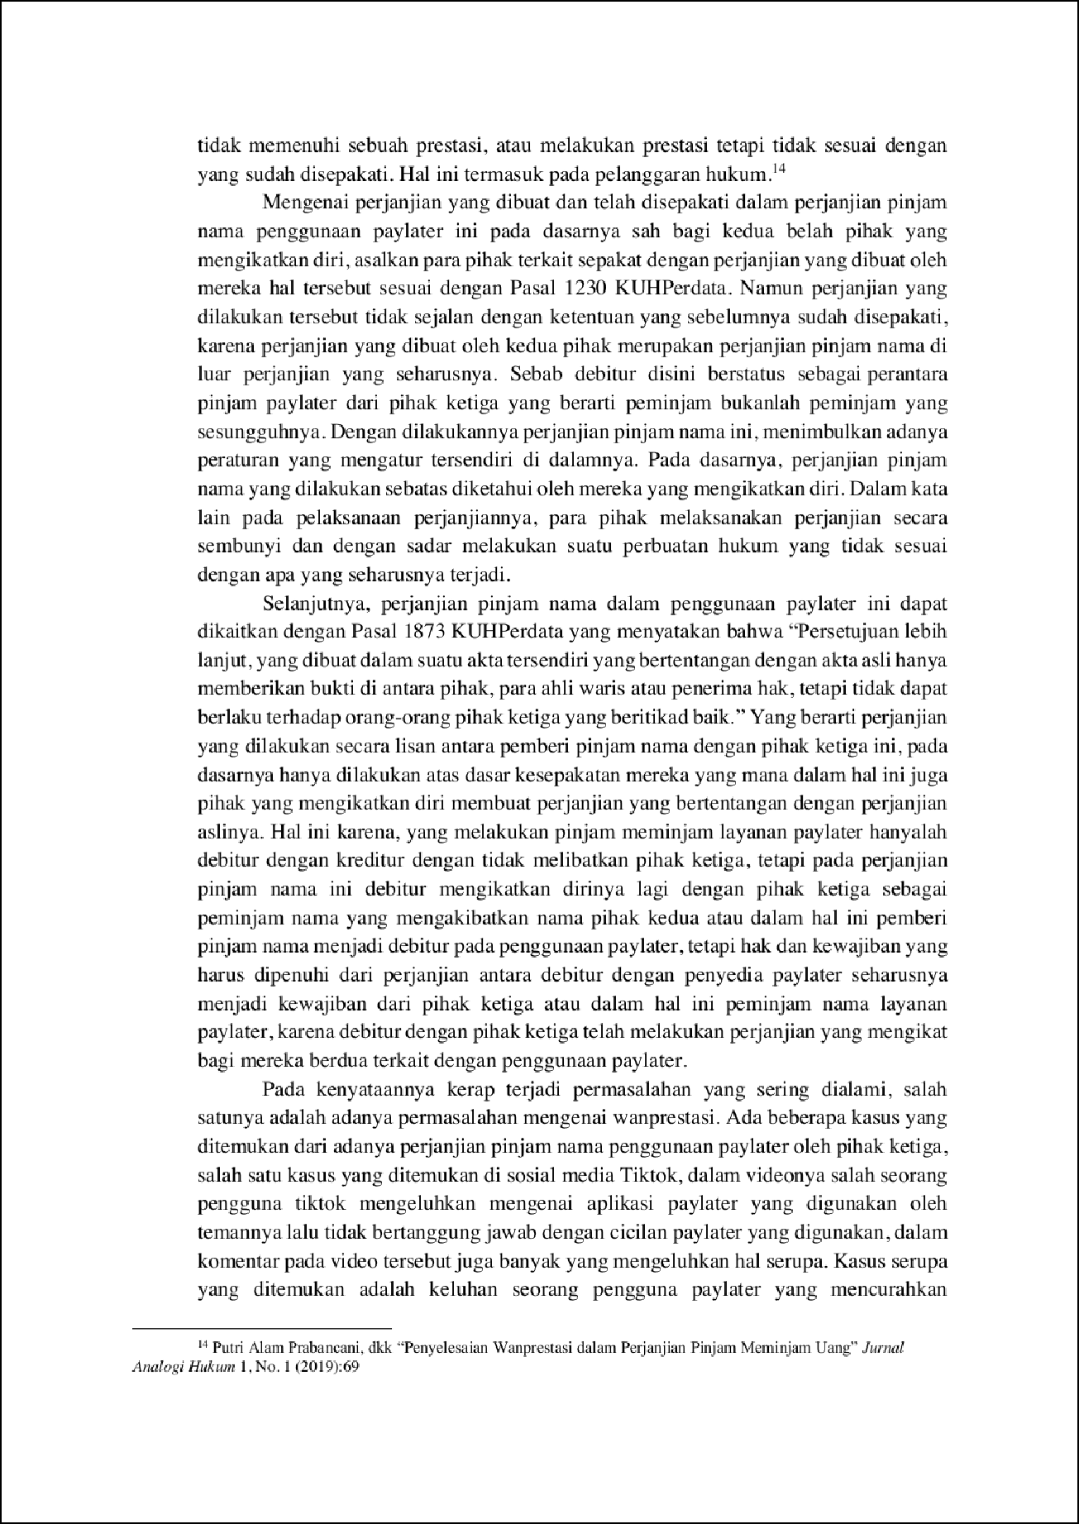

45

5

5

1

1

1

6

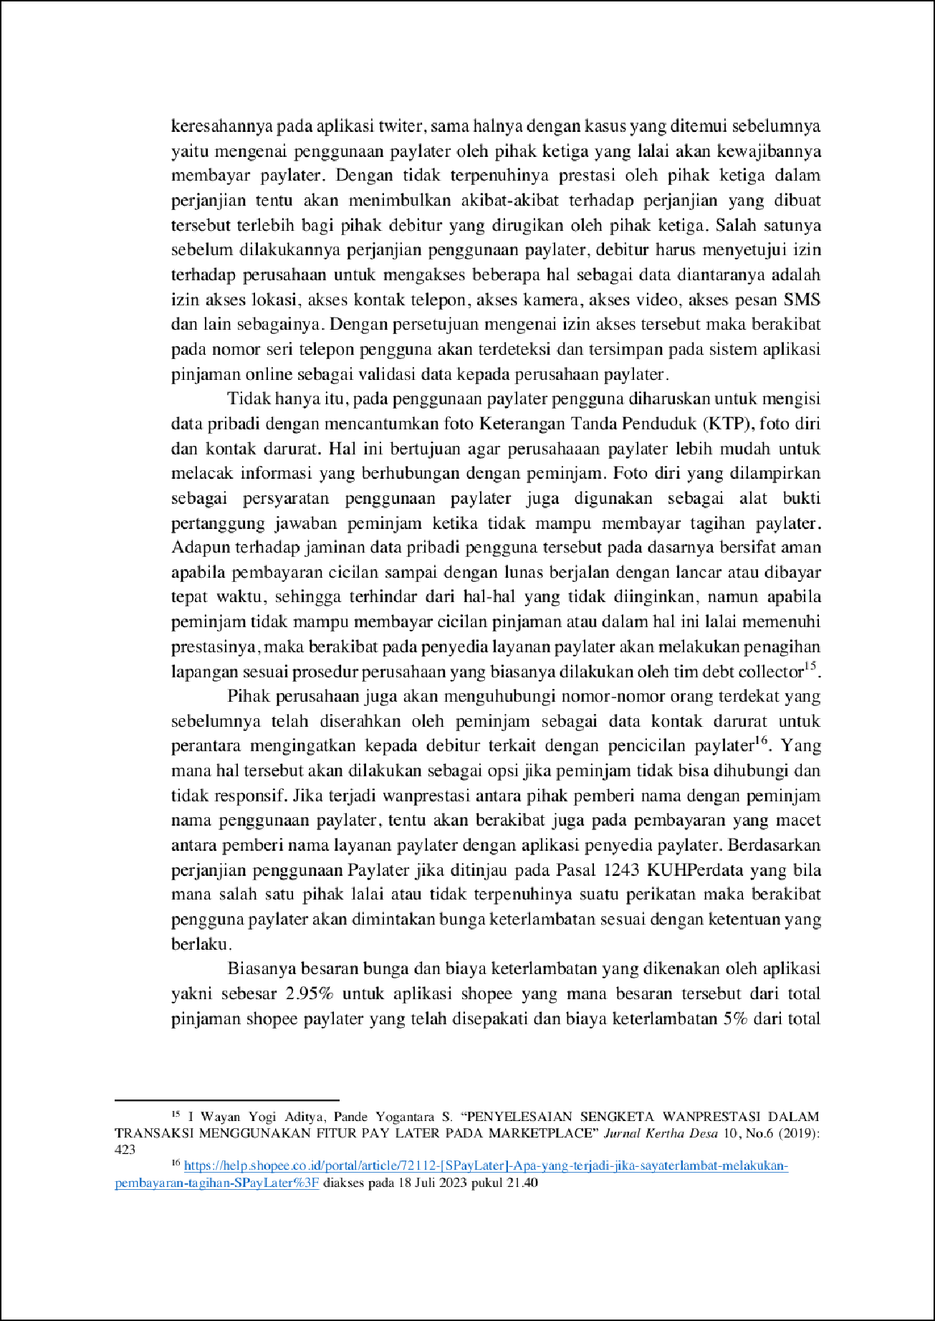

2

2

2

2

9

2

4

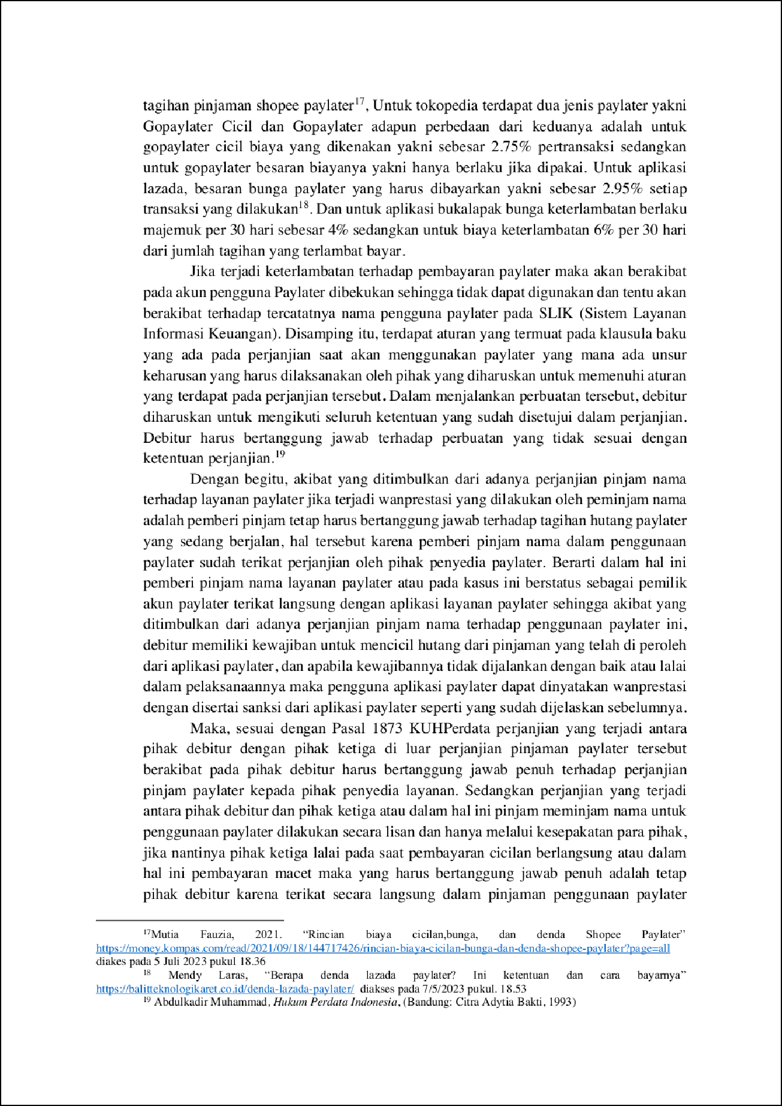

32

7

1

7

5

5

18

14

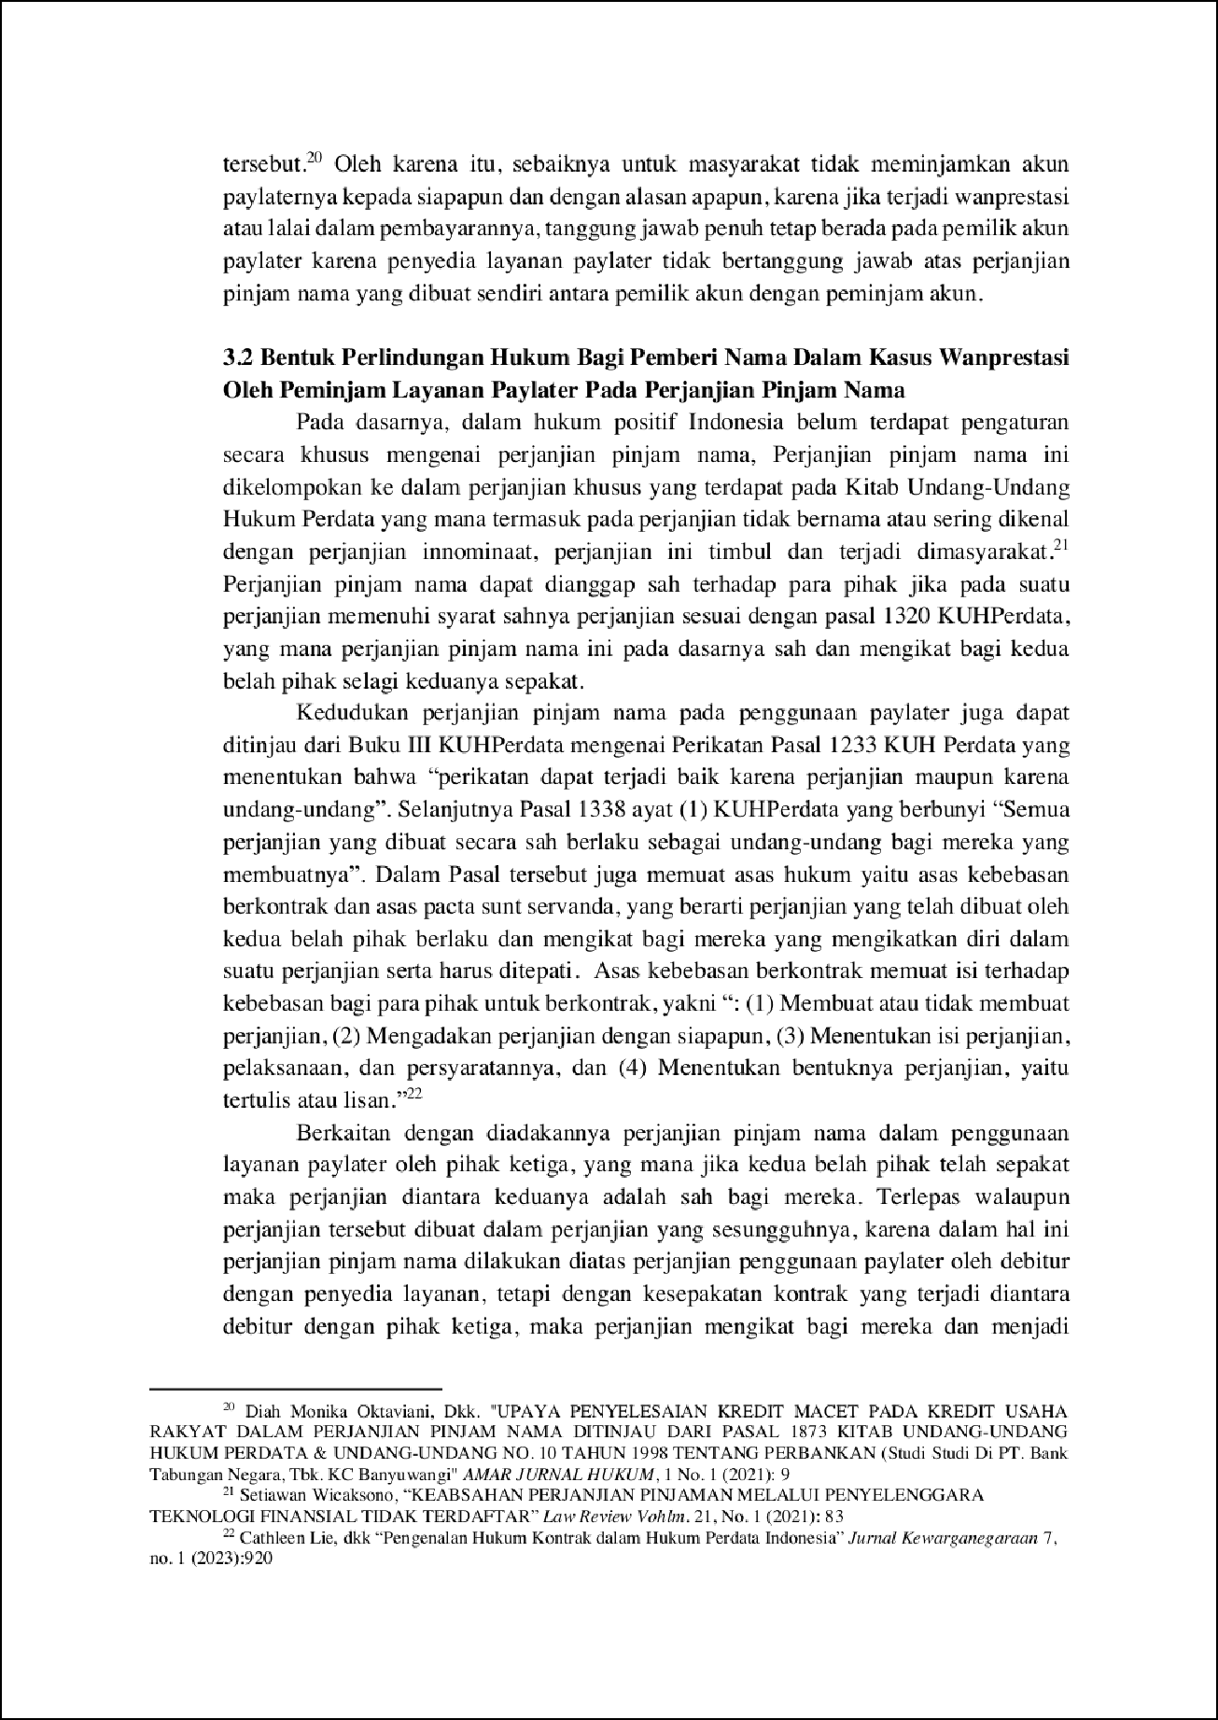

34

14

9

46

11

28

50

2

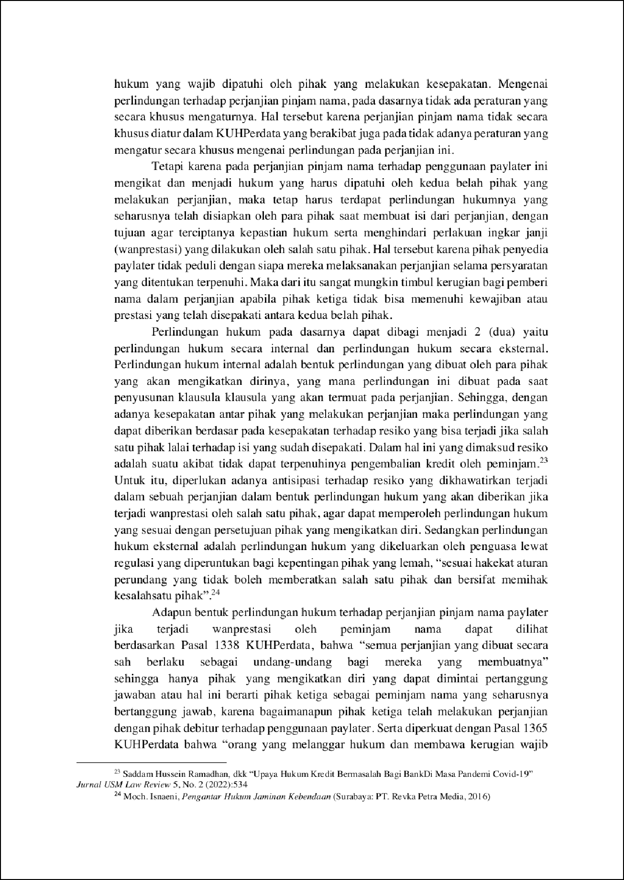

15

11

9

1

1

13

20

47

29

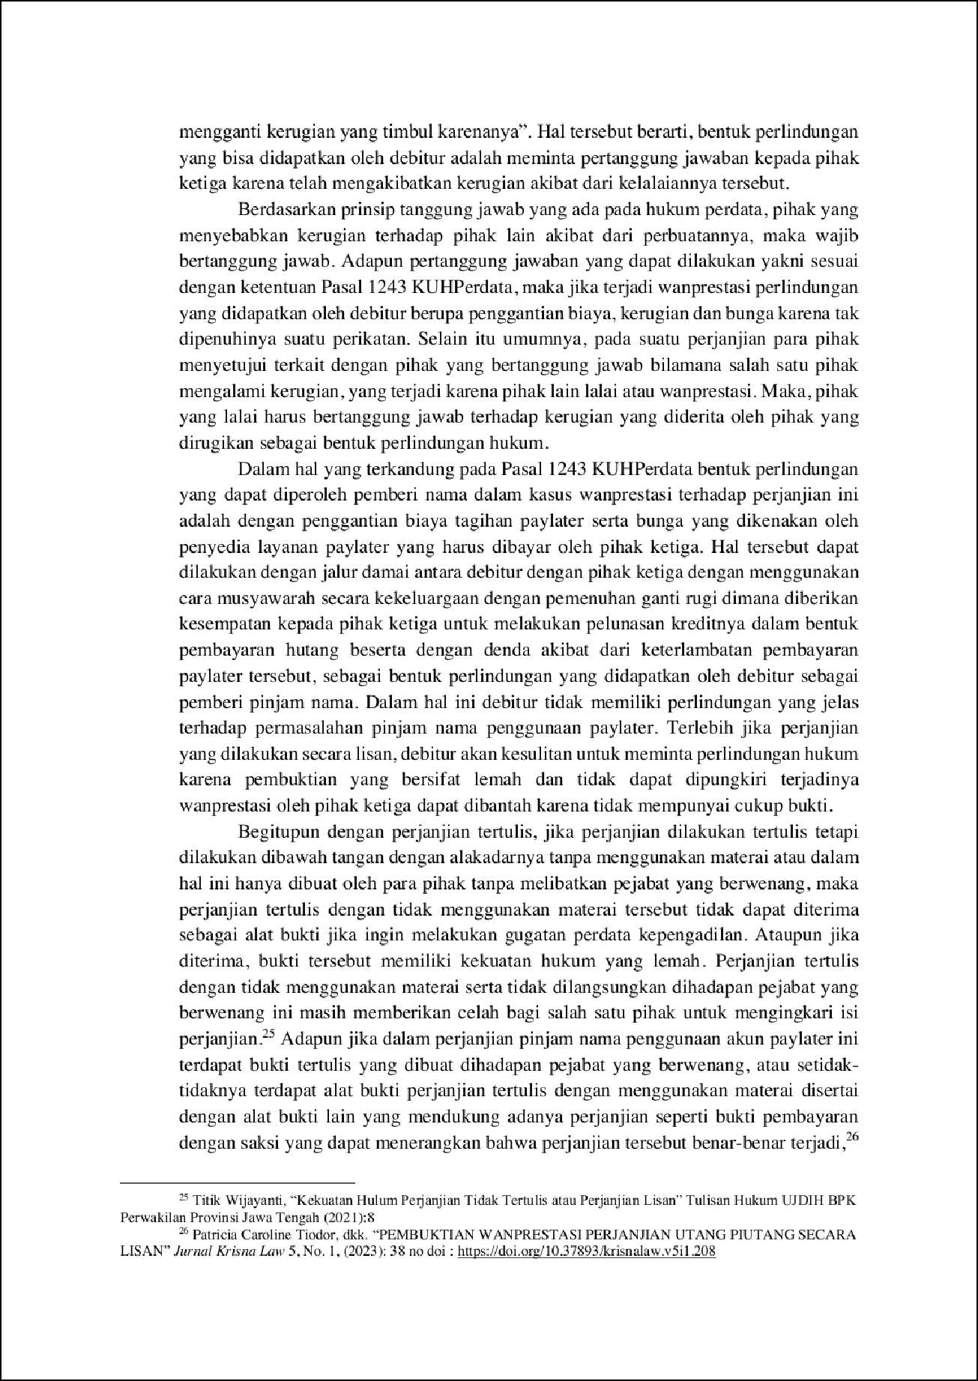

30

49

37

12

12

35

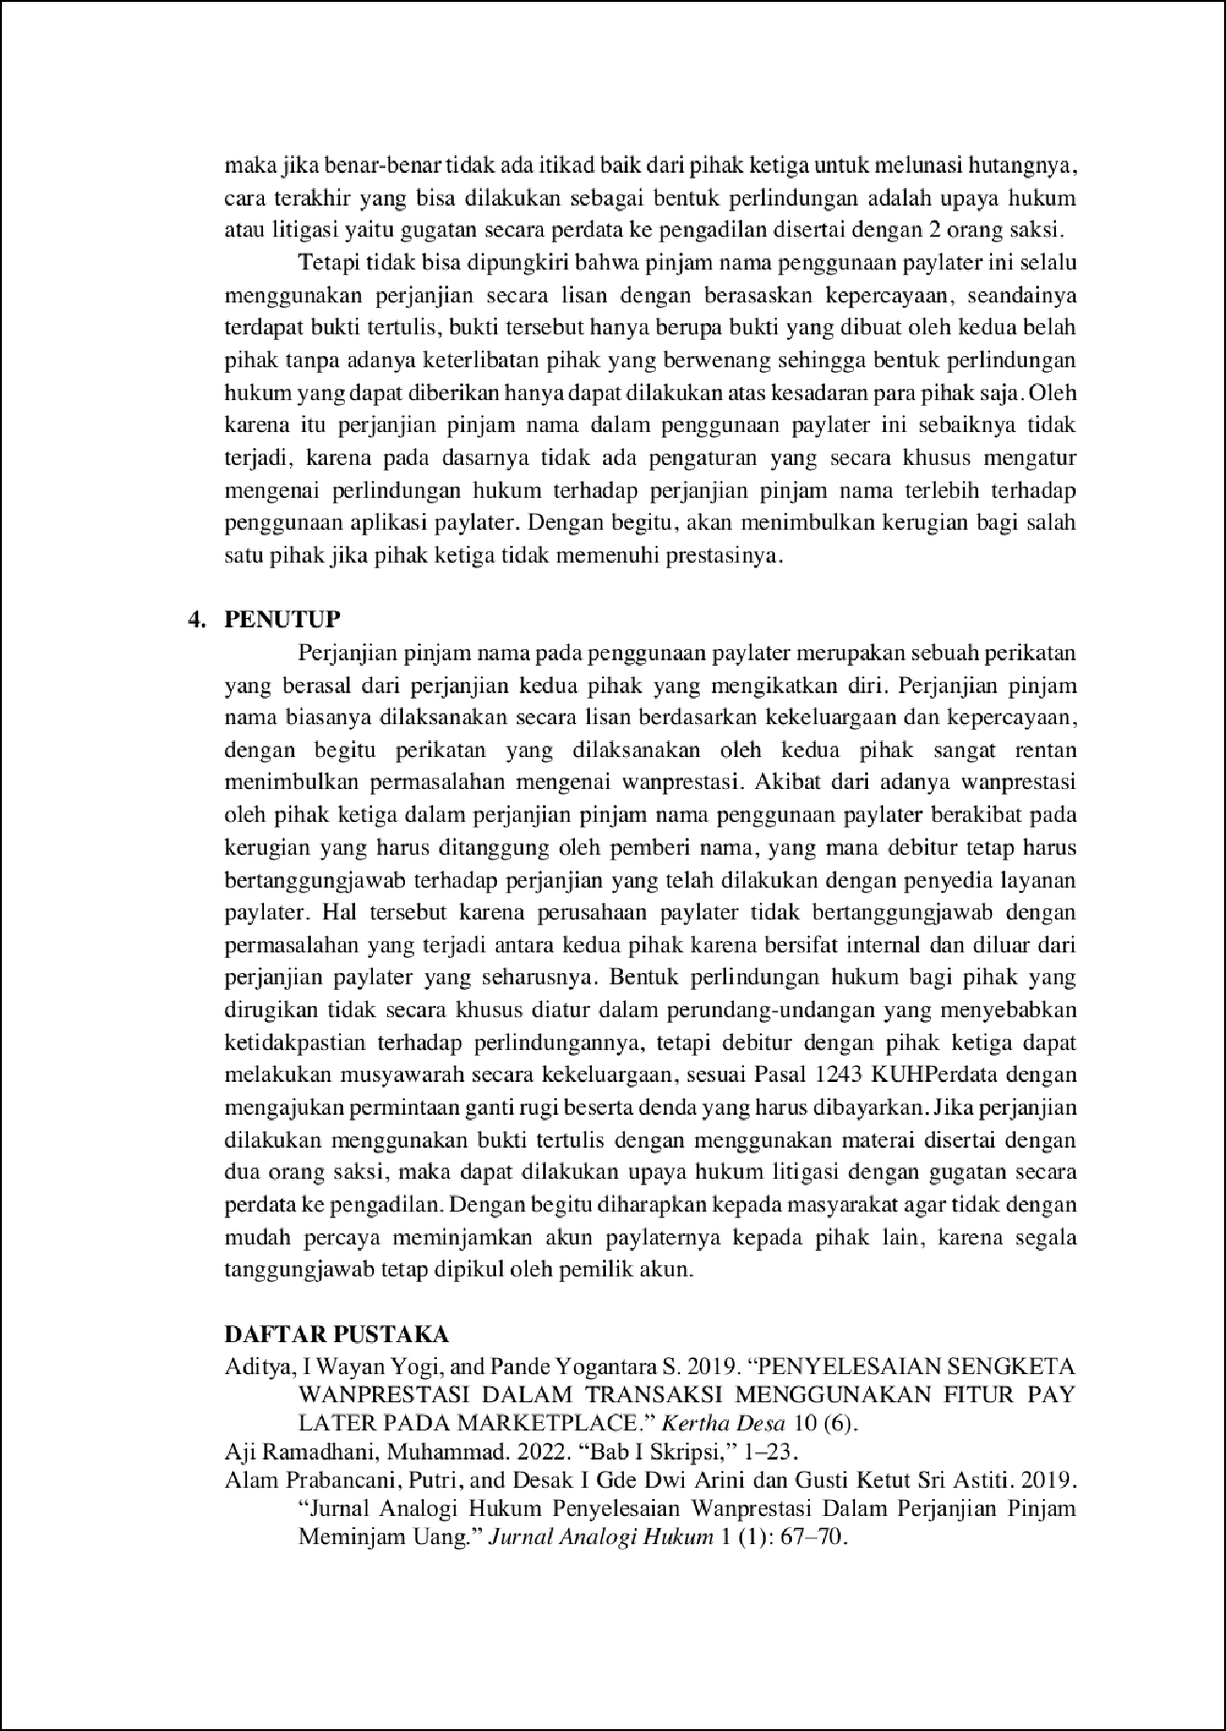

39

38

3

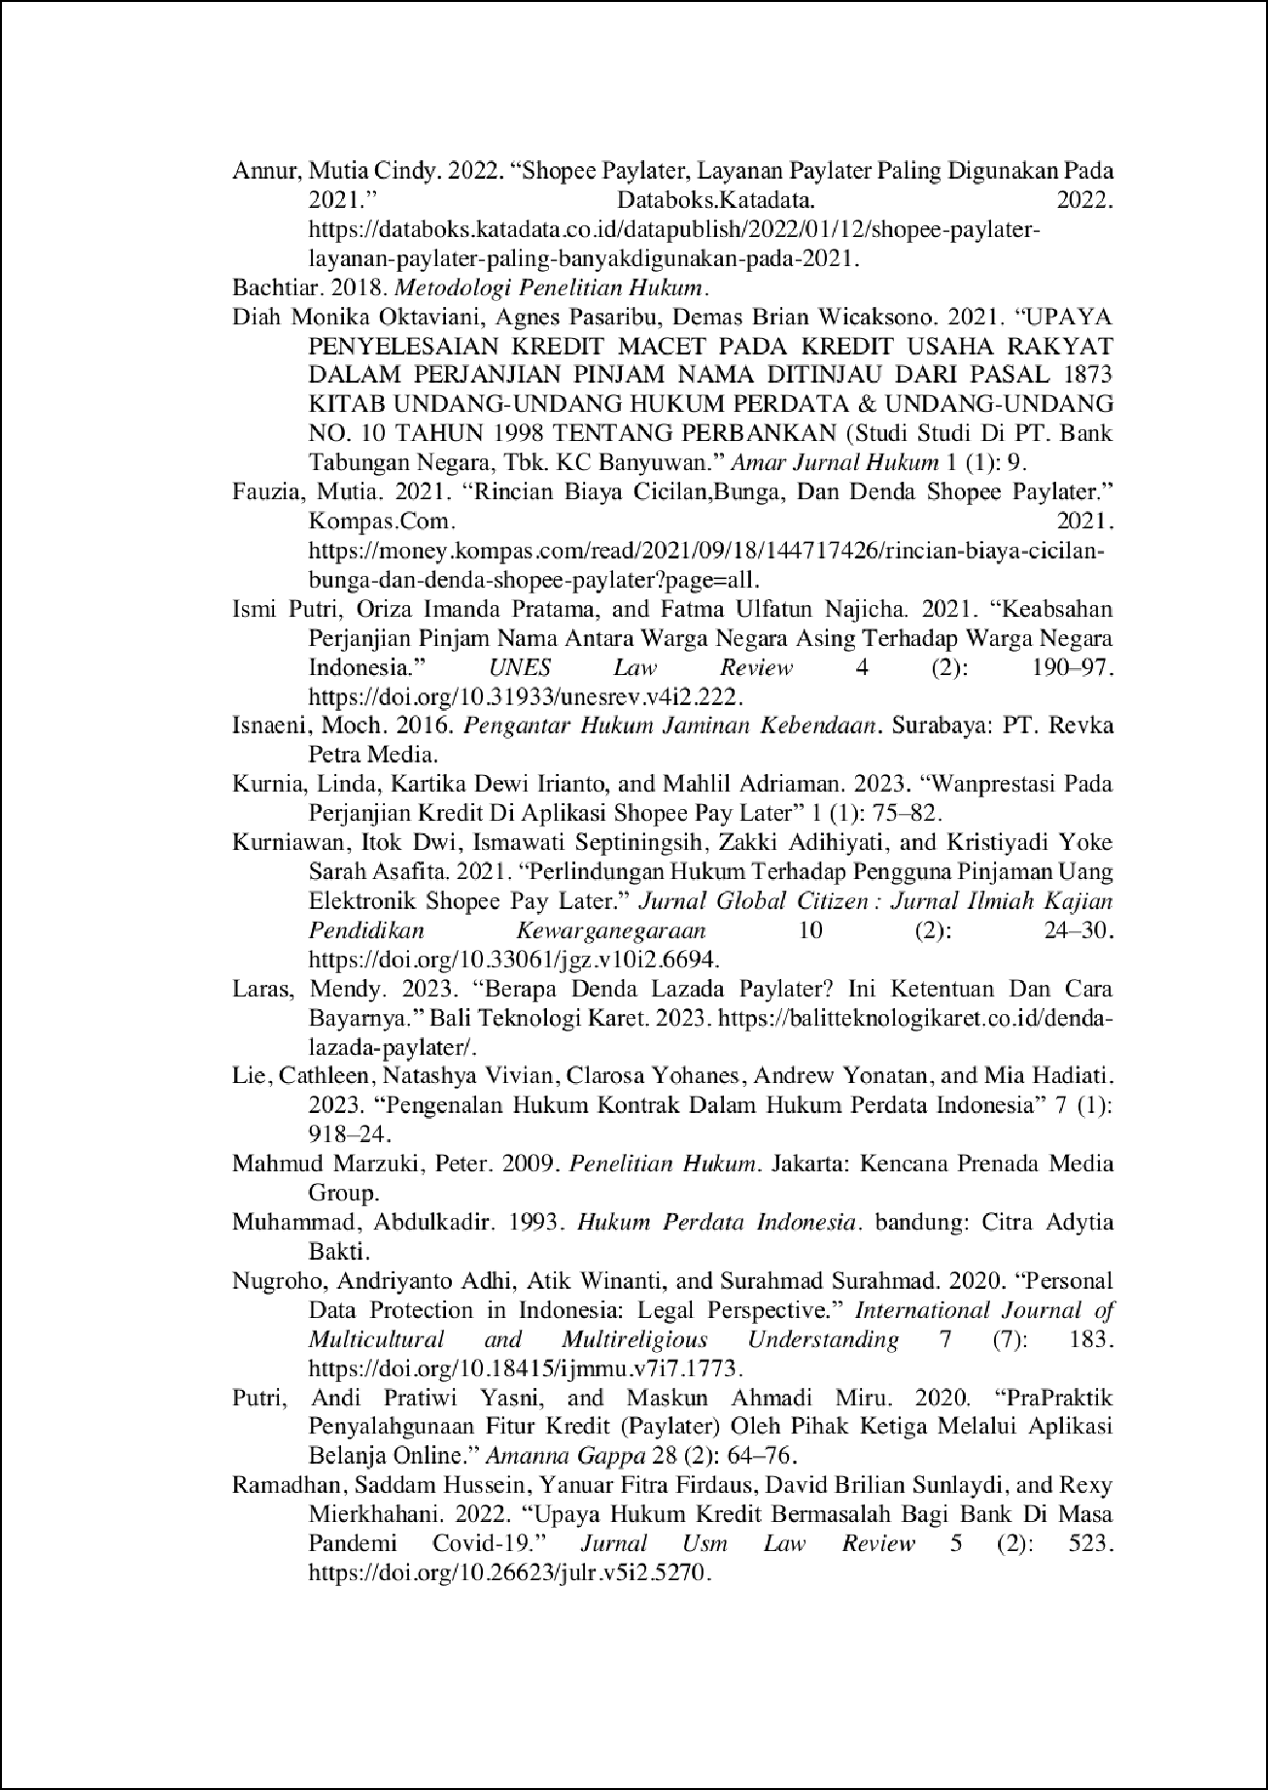

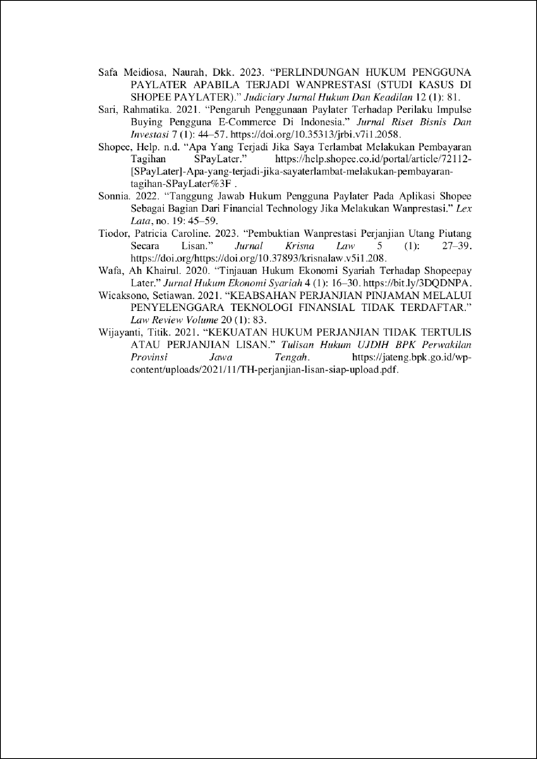

turnitin 6

ORIGINALITY REPORT

20

%

SIMILARITY INDEX

19%

INTERNET SOURCES

5%

PUBLICATIONS

6%

STUDENT PAPERS

PRIMARY SOURCES

digilib.uinsgd.ac.id

Internet Source %

1

2

2

ojs.unud.ac.id

Internet Source %

2

1

journals.usm.ac.id

Internet Source %

3

1

jurnal.umsb.ac.id

Internet Source %

4

1

jurnal.untag-banyuwangi.ac.id

Internet Source %

5

1

[www.researchgate.net](http://www.researchgate.net/)

Internet Source %

6

1

journal.fh.unsri.ac.id

Internet Source %

7

1

digilib.uinkhas.ac.id

Internet Source %

8

1

repository.umsu.ac.id

Internet Source %

9

10

11

12

13

14

15

16

17

18

19

20

21

repository.radenintan.ac.id

Internet Source

digilib.uns.ac.id

Internet Source

jateng.bpk.go.id

Internet Source

Submitted to Universitas Jember

Student Paper

dspace.uii.ac.id

Internet Source

journal.trunojoyo.ac.id

Internet Source

kopma.student.uny.ac.id

Internet Source

journal.unnes.ac.id

Internet Source

money.kompas.com

Internet Source

Submitted to UIN Raden Intan Lampung

Student Paper

Submitted to Universitas Airlangga

Student Paper

garuda.kemdikbud.go.id

Internet Source

1%

<1%

<1%

<1%

<1%

<1%

<1%

<1%

<1%

<1%

<1%

<1%

22

23

24

25

26

27

28

29

30

31

32

33

repository.uin-suska.ac.id

Internet Source

Submitted to Udayana University

Student Paper

fh.upnvj.ac.id

Internet Source

ejournal.iainu-kebumen.ac.id

Internet Source

eprints.unram.ac.id

Internet Source

Submitted to Universitas Negeri Surabaya The State University of Surabaya

Student Paper

budi399.wordpress.com

Internet Source

es.scribd.com

Internet Source

repository.iainpare.ac.id

Internet Source

repository.unej.ac.id

Internet Source

[www.coursehero.com](http://www.coursehero.com/)

Internet Source

curahanhatipertiwi.blogspot.com

Internet Source

<1%

<1%

<1%

<1%

<1%

<1%

<1%

<1%

<1%

<1%

<1%

34

35

36

37

38

39

40

41

42

43

e-repository.perpus.iainsalatiga.ac.id

Internet Source

journal.upy.ac.id

Internet Source

jurnal.unej.ac.id

Internet Source

[www.scribd.com](http://www.scribd.com/)

Internet Source

123dok.com

Internet Source

Irwan Gomulja, Habib Adjie. "Pengendalian Asas Kebebasan Berkontrak Dalam Sistem Pre Project Selling", Law and Justice, 2020

Publication

Submitted to Universitas Pamulang

Student Paper

core.ac.uk

Internet Source

fhukum.unpatti.ac.id

Internet Source

journal.unhas.ac.id

Internet Source

<1%

<1%

<1%

<1%

<1%

<1%

<1%

<1%

<1%

<1%

<1%

44

45

46

47

48

49

50

jurnal.um-tapsel.ac.id

Internet Source

wongndoko.blogspot.com

Internet Source

vdocuments.site

Internet Source

ariessuryabuana.blogspot.com

Internet Source

repo.unand.ac.id

Internet Source

tiarramon.wordpress.com

Internet Source

Submitted to Universitas Diponegoro

Student Paper

<1%

<1%

<1%

<1%

<1%

<1%

<1%

Exclude quotes On Exclude bibliography On

Exclude matches Oﬀ

turnitin 6

GRADEMARK REPORT

FINAL GRADE

# /0

GENERAL COMMENTS

**Instructor**

PAGE 1

PAGE 2

PAGE 3

PAGE 4

PAGE 5

PAGE 6

PAGE 7

PAGE 8

PAGE 9

PAGE 10

PAGE 11

PAGE 12

PAGE 13