# Tanggung Jawab Perdata Terhadap Kreator Konten Atas Penyebaran Komik Online di Aplikasi TikTok.

*by* Julia Putri

**Submission date:** 26-Aug-2023 10:54PM (UTC-0700)

**Submission ID:** 2151886078

**File name:** ator_Konten_Atas_Penyebaran_Komik_Online_di_Aplikasi_TikTok.docx (67.45K)

**Word count:** 4180

**Character count:** 27602

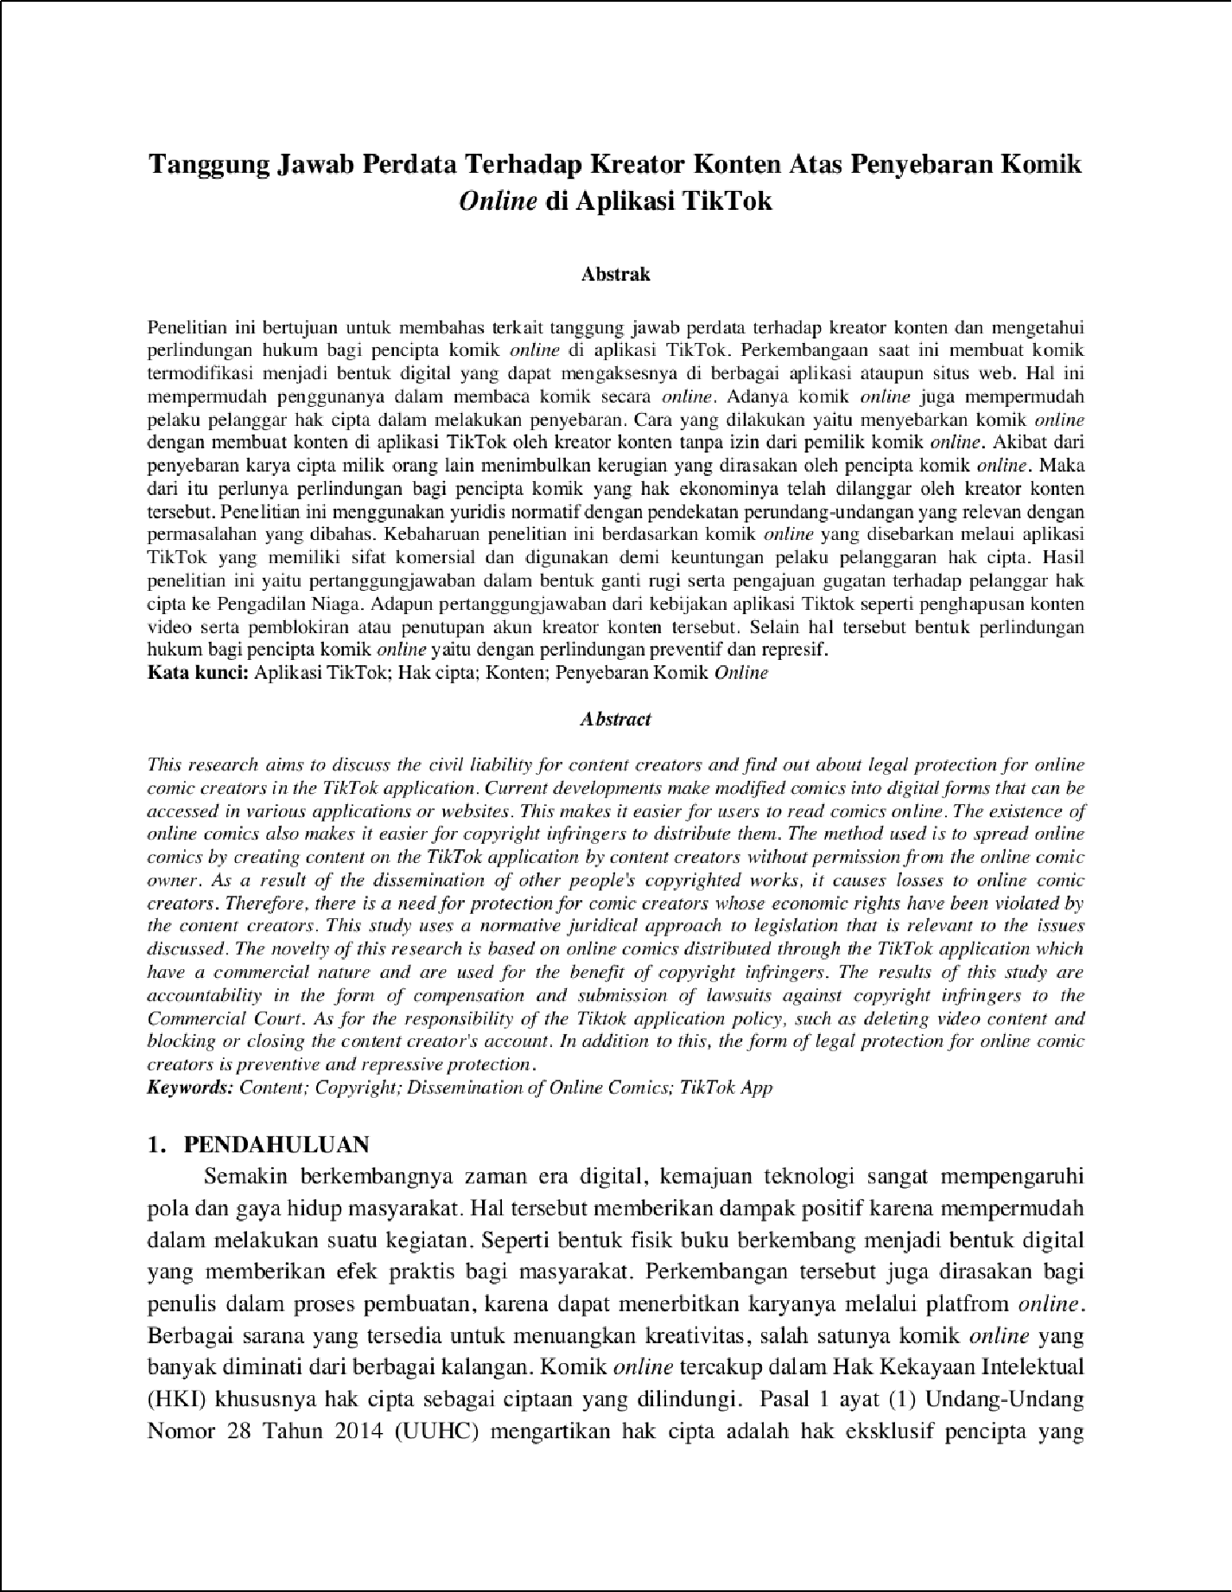

1

7

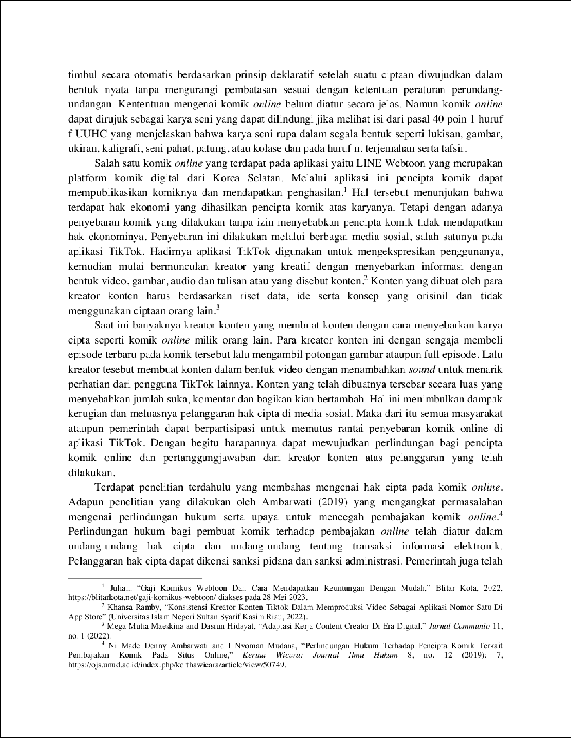

21

2

22

11

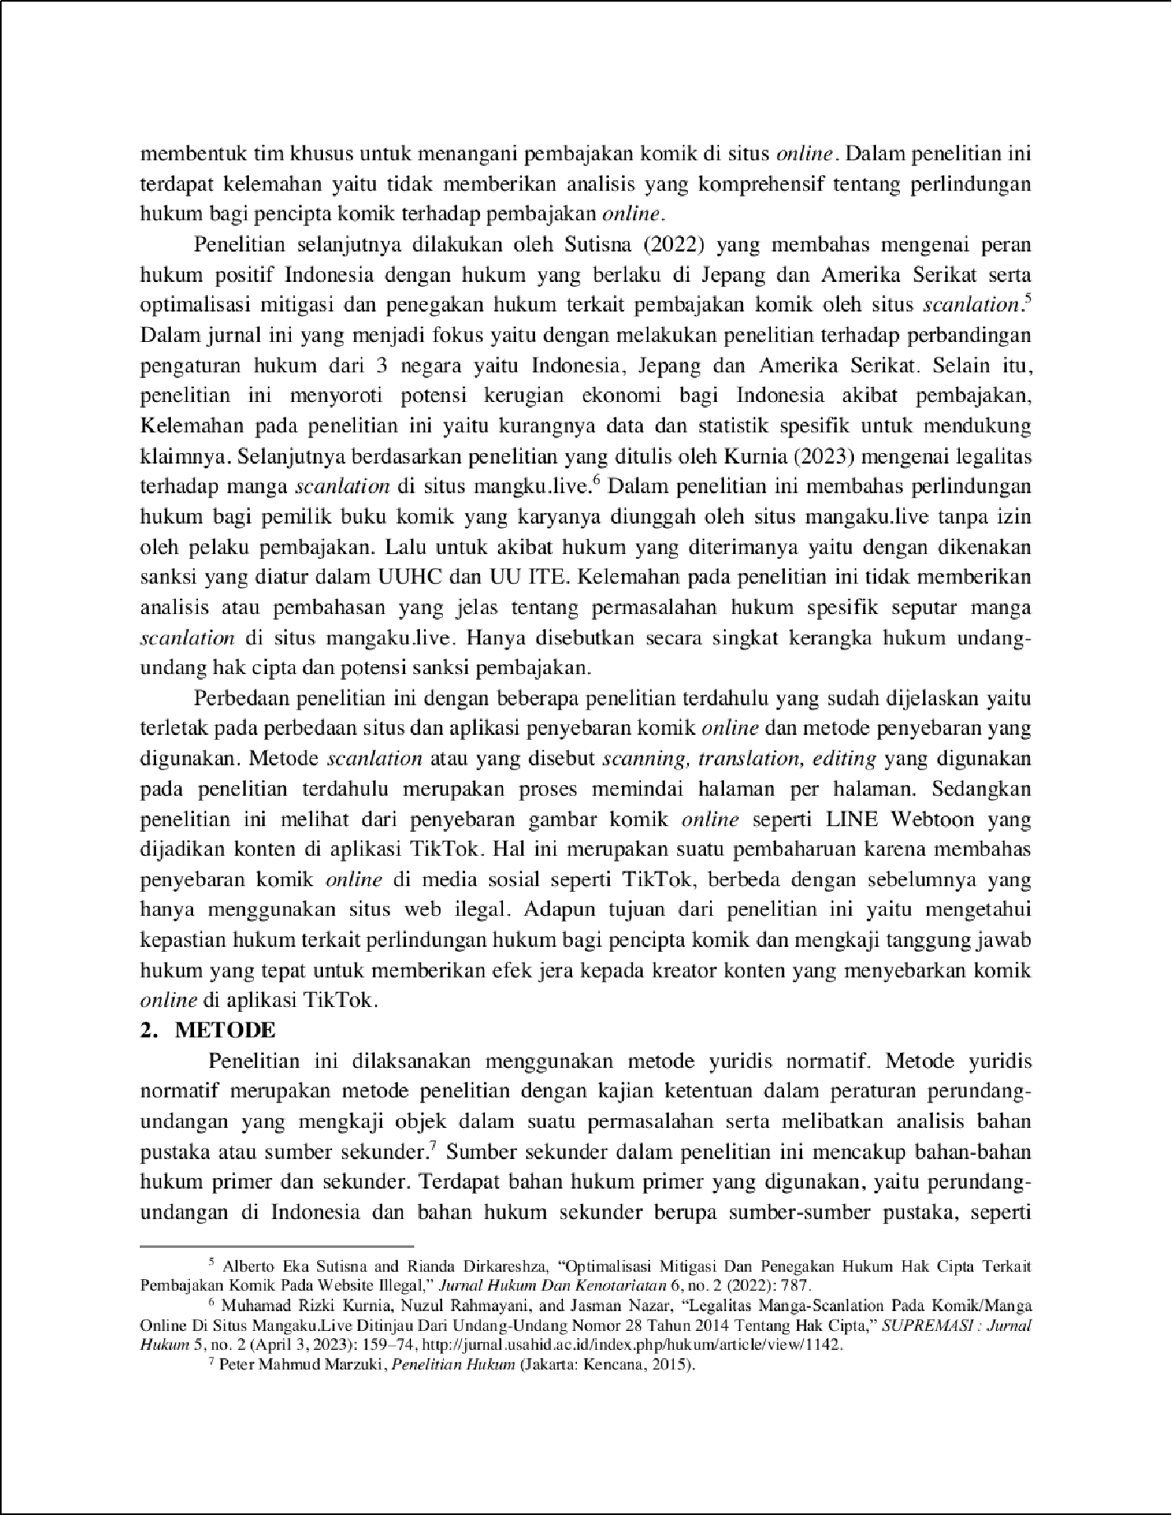

10

6

6

16

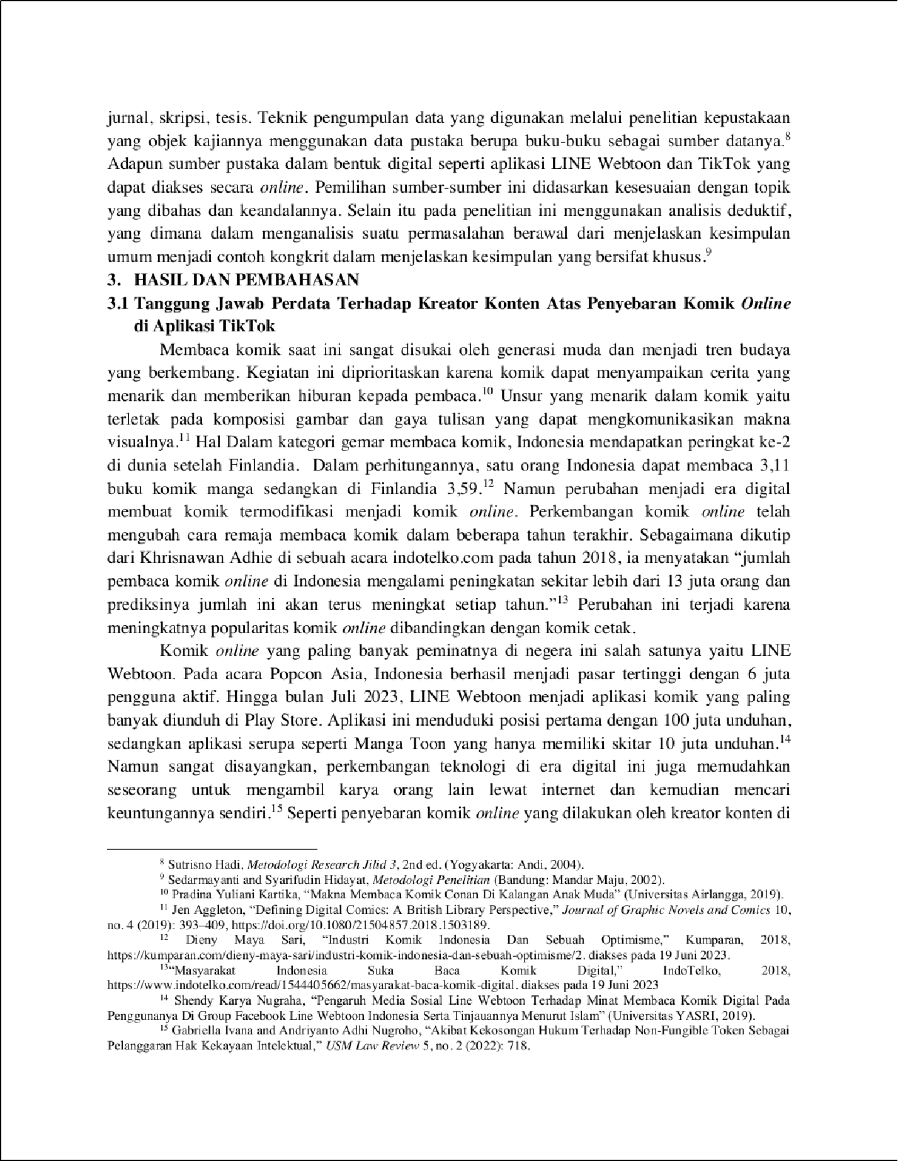

1

20

6

18

1

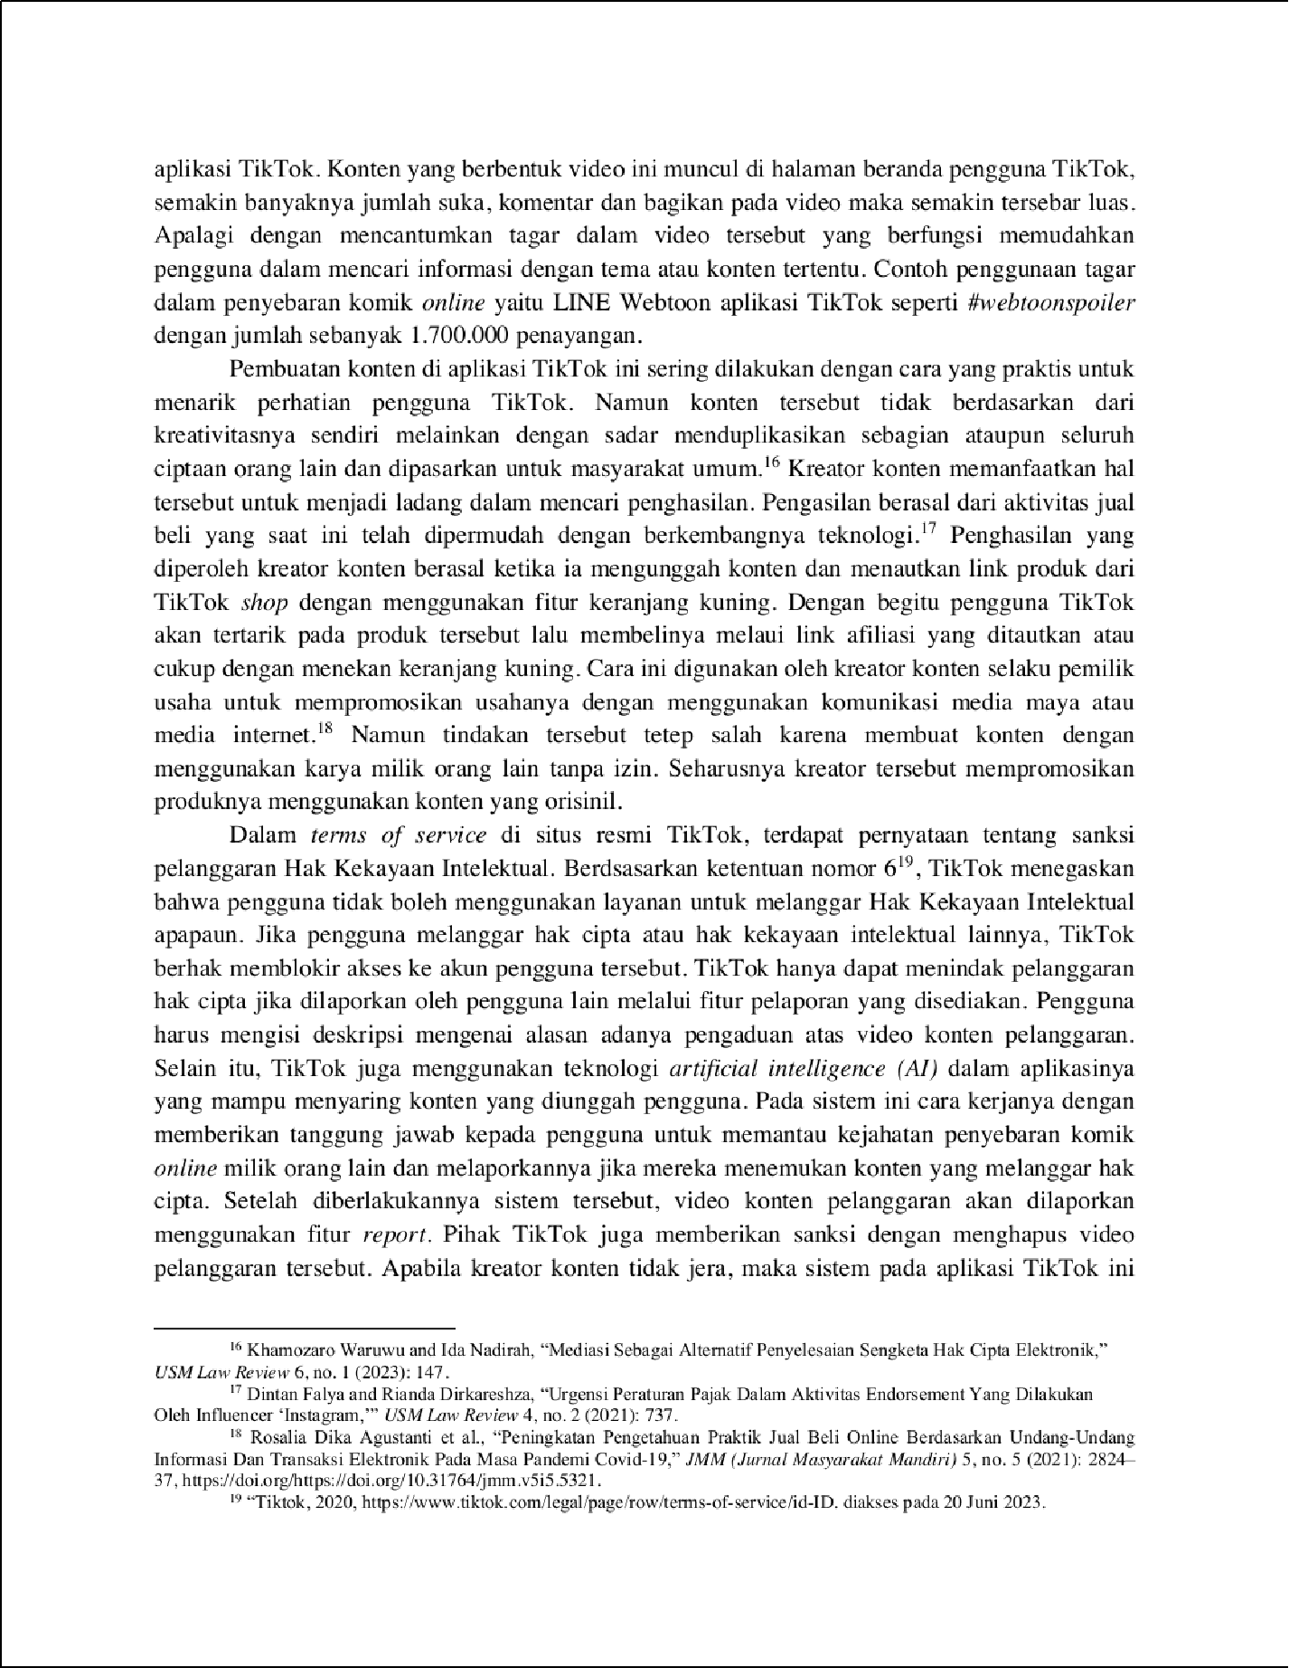

1

2

19

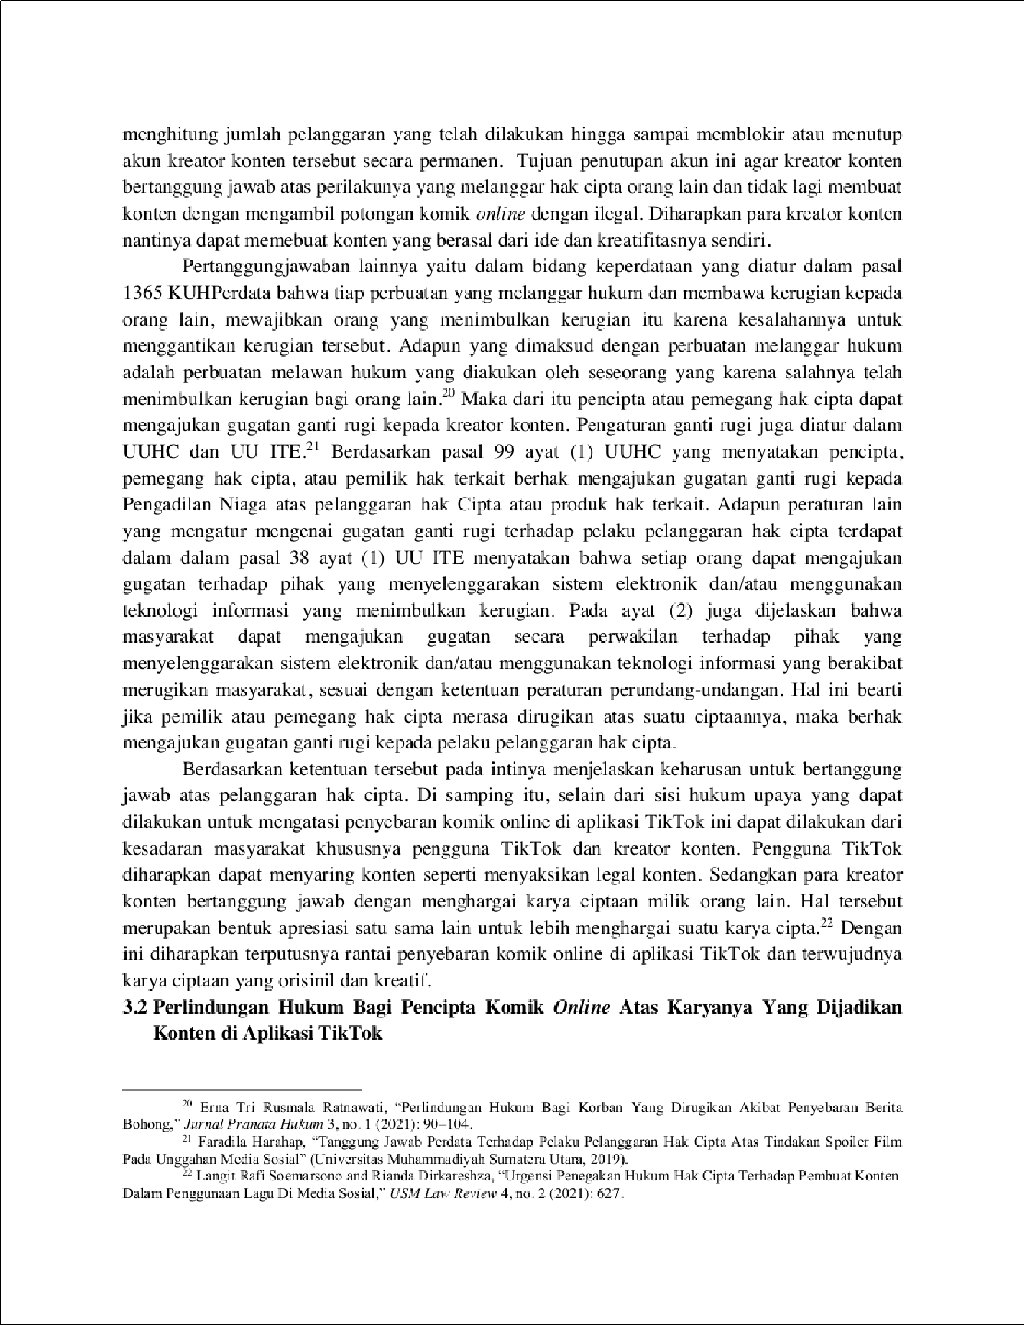

5

12

8

4

8

1

9

10

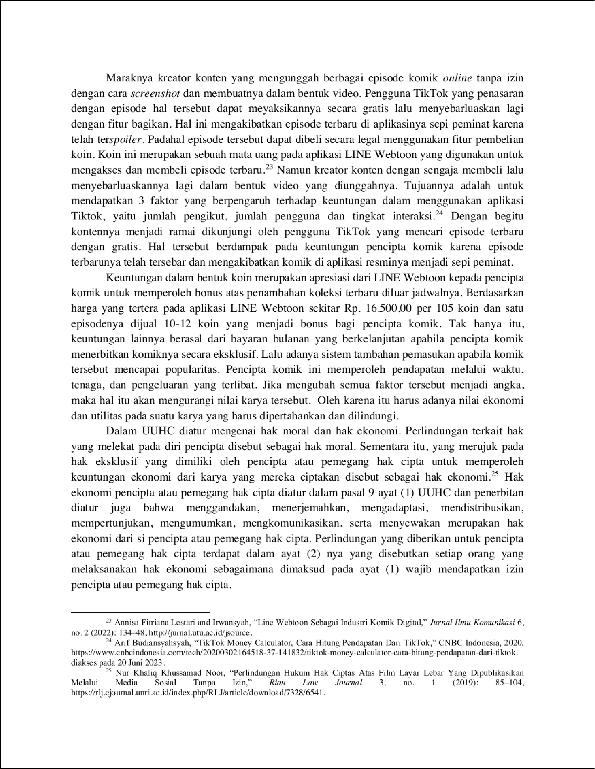

2

2

15

14

17

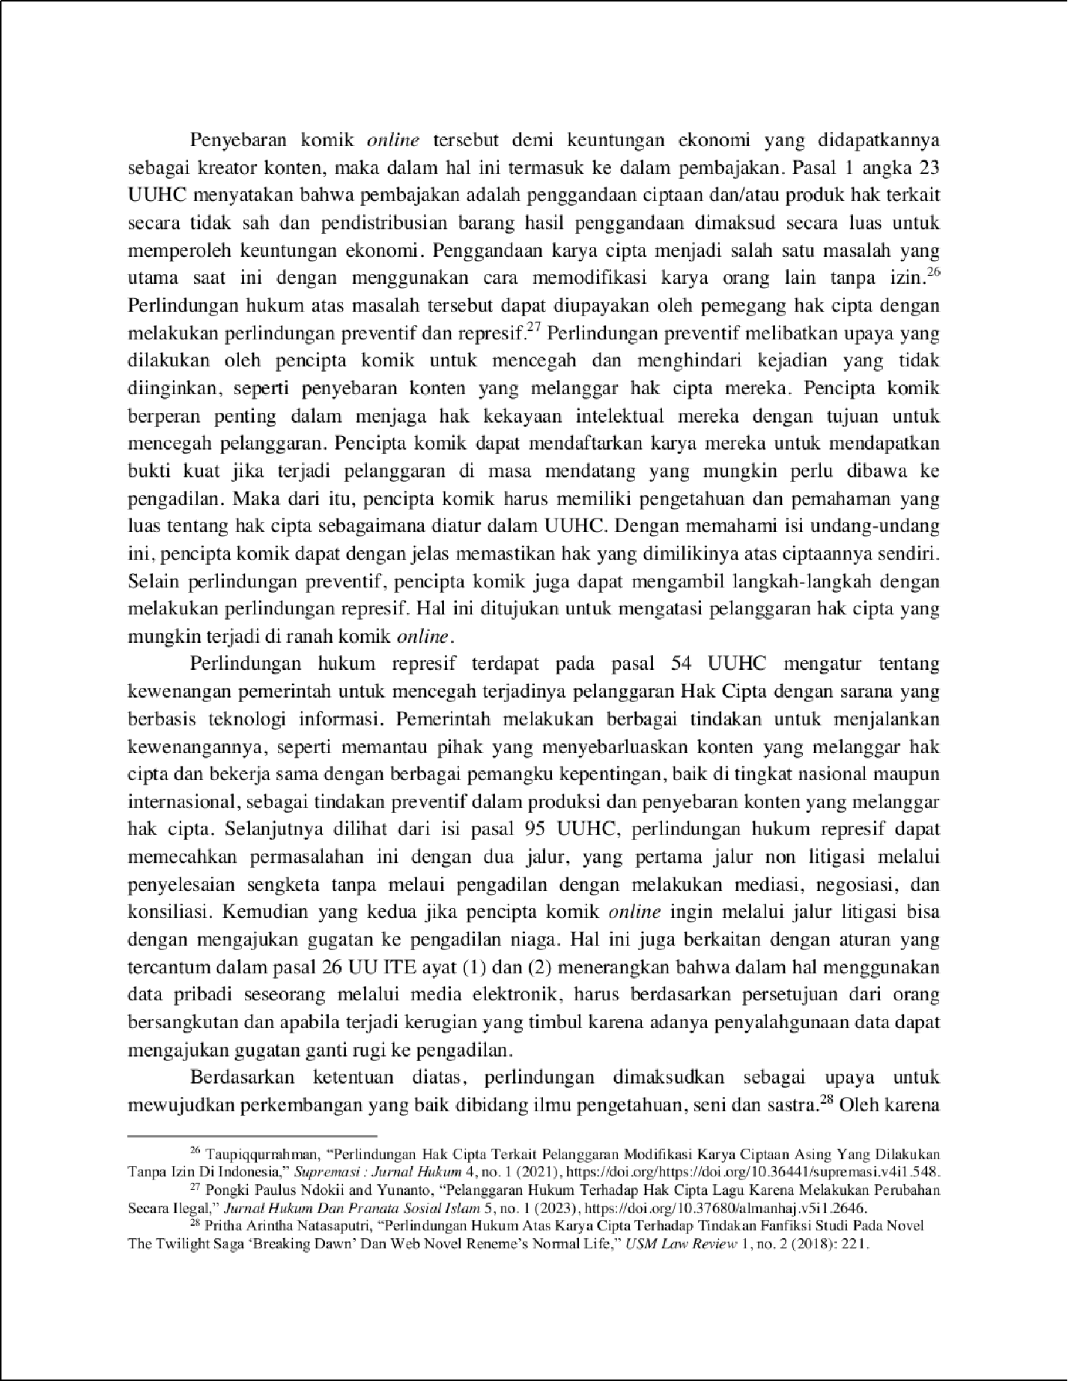

13

9

3

3

1

3

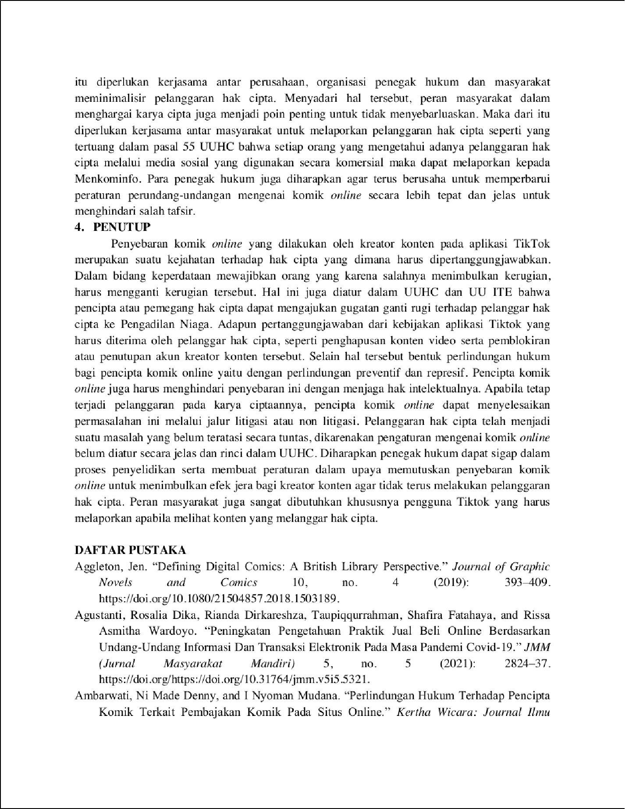

2

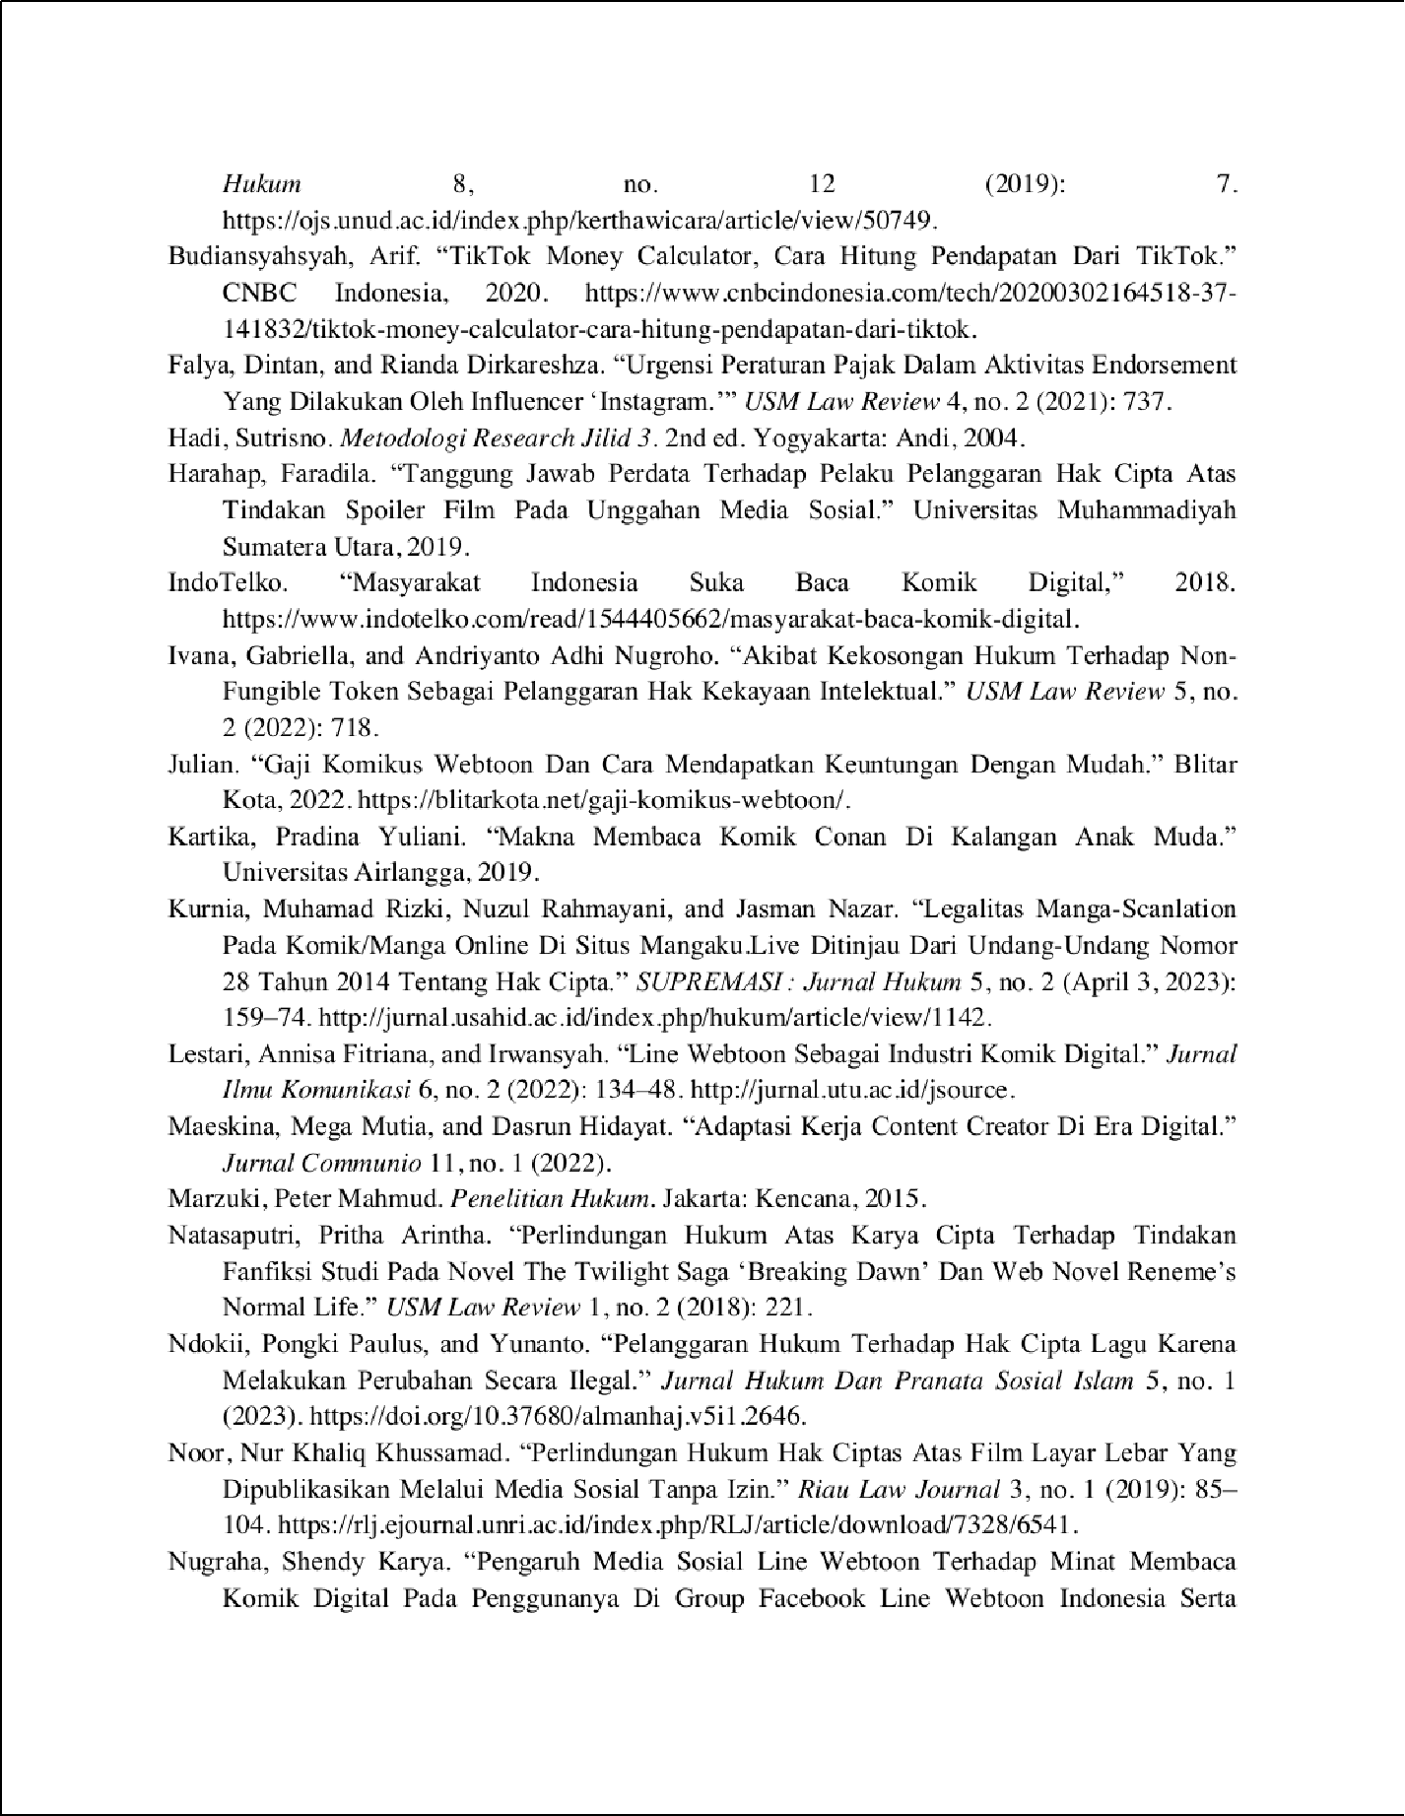

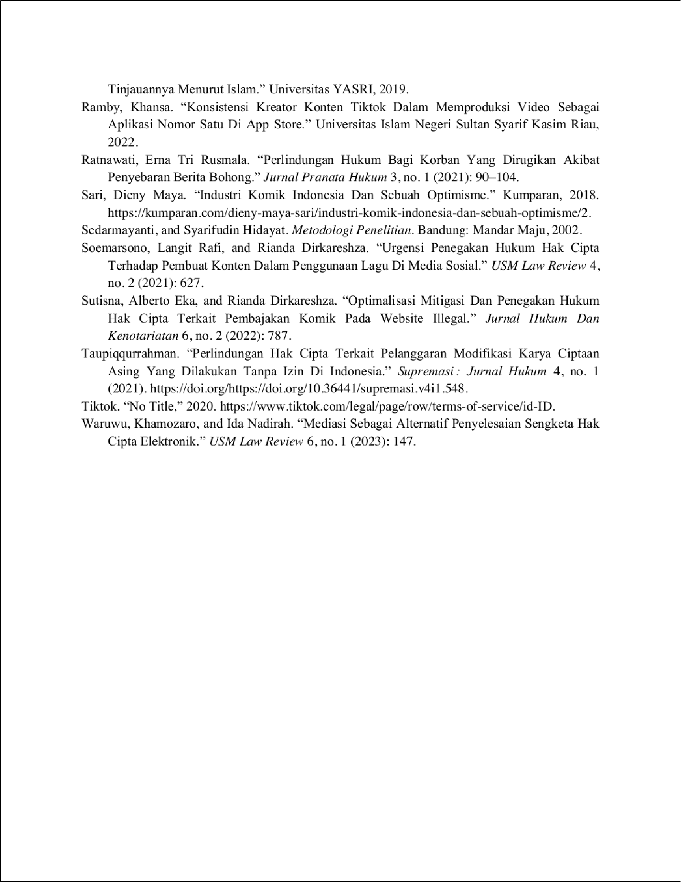

Tanggung Jawab Perdata Terhadap Kreator Konten Atas Penyebaran Komik Online di Aplikasi TikTok.

18

ORIGINALITY REPORT

%

SIMILARITY INDEX

18%

INTERNET SOURCES

10%

PUBLICATIONS

10%

STUDENT PAPERS

PRIMARY SOURCES

journals.usm.ac.id

Internet Source %

1

2

1

ojs.unud.ac.id

Internet Source %

2

1

ejournal.insuriponorogo.ac.id

Internet Source %

3

1

repository.uhn.ac.id

Internet Source %

4

1

ejournal.widyamataram.ac.id

Internet Source %

5

1

riset.unisma.ac.id

Internet Source %

6

1

digilib.uinsby.ac.id

Internet Source %

7

1

repository.umsu.ac.id

Internet Source %

8

1

digilib.uinkhas.ac.id

Internet Source %

9

10

11

12

13

14

15

16

17

18

19

20

[www.researchgate.net](http://www.researchgate.net/)

Internet Source %

1

repository.unsri.ac.id

1

Internet Source %

Submitted to Universitas Negeri Surabaya The State University of Surabaya

1%

Student Paper

[www.bambangmujiyono.com](http://www.bambangmujiyono.com/)

1

Internet Source %

Submitted to UPN Veteran Jakarta

1

Student Paper %

Submitted to Universitas Jember

1

Student Paper %

jurnal.usahid.ac.id

1

Internet Source %

Submitted to UIN Syarif Hidayatullah Jakarta

1

Student Paper %

digilib.yarsi.ac.id

1

Internet Source %

[www.neliti.com](http://www.neliti.com/)

1

Internet Source %

Submitted to Sveučilite u Zadru | NOVA LICENCA

1%

Student Paper

21

22

Submitted to Universitas Hang Tuah Surabaya

Student Paper %

1

repository.uin-suska.ac.id

1

Internet Source %

Exclude quotes Oﬀ Exclude bibliography On

Exclude matches < 1%

Tanggung Jawab Perdata Terhadap Kreator Konten Atas Penyebaran Komik Online di Aplikasi TikTok.

GRADEMARK REPORT

FINAL GRADE

# /0

PAGE 1

PAGE 2

PAGE 3

PAGE 4

PAGE 5

PAGE 6

PAGE 7

PAGE 8

PAGE 9

PAGE 10

PAGE 11

GENERAL COMMENTS