# NASKAH JURNAL KARTIKA FH UPNVJ HAK CIPTA

*by* Cek Turnitin

**Submission date:** 23-Jul-2023 09:39AM (UTC-0500)

**Submission ID:** 2135357654

**File name:** NASKAH_JURNAL_KARTIKA_FH_UPNVJ_HAK_CIPTA.pdf (174.23K)

**Word count:** 5102

**Character count:** 29357

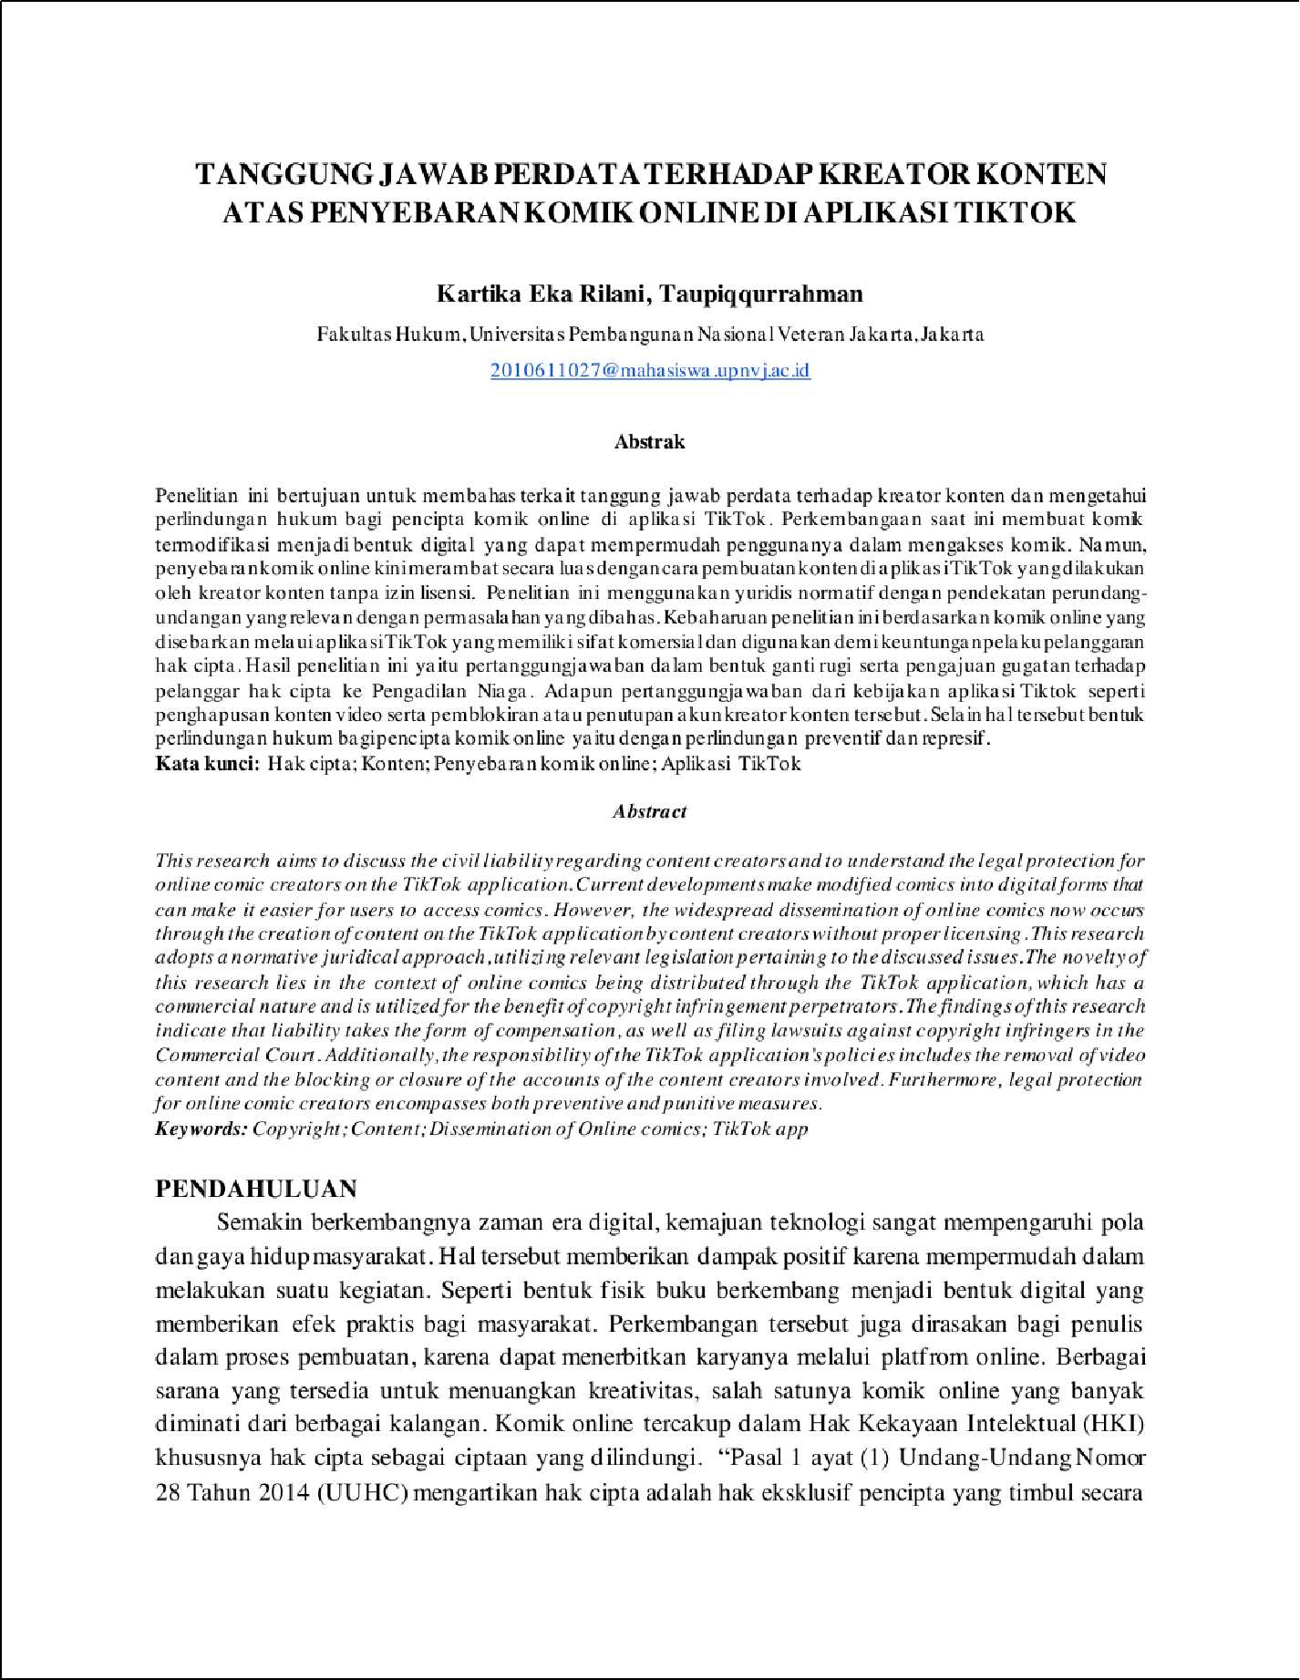

13

16 16

9

9

29

5

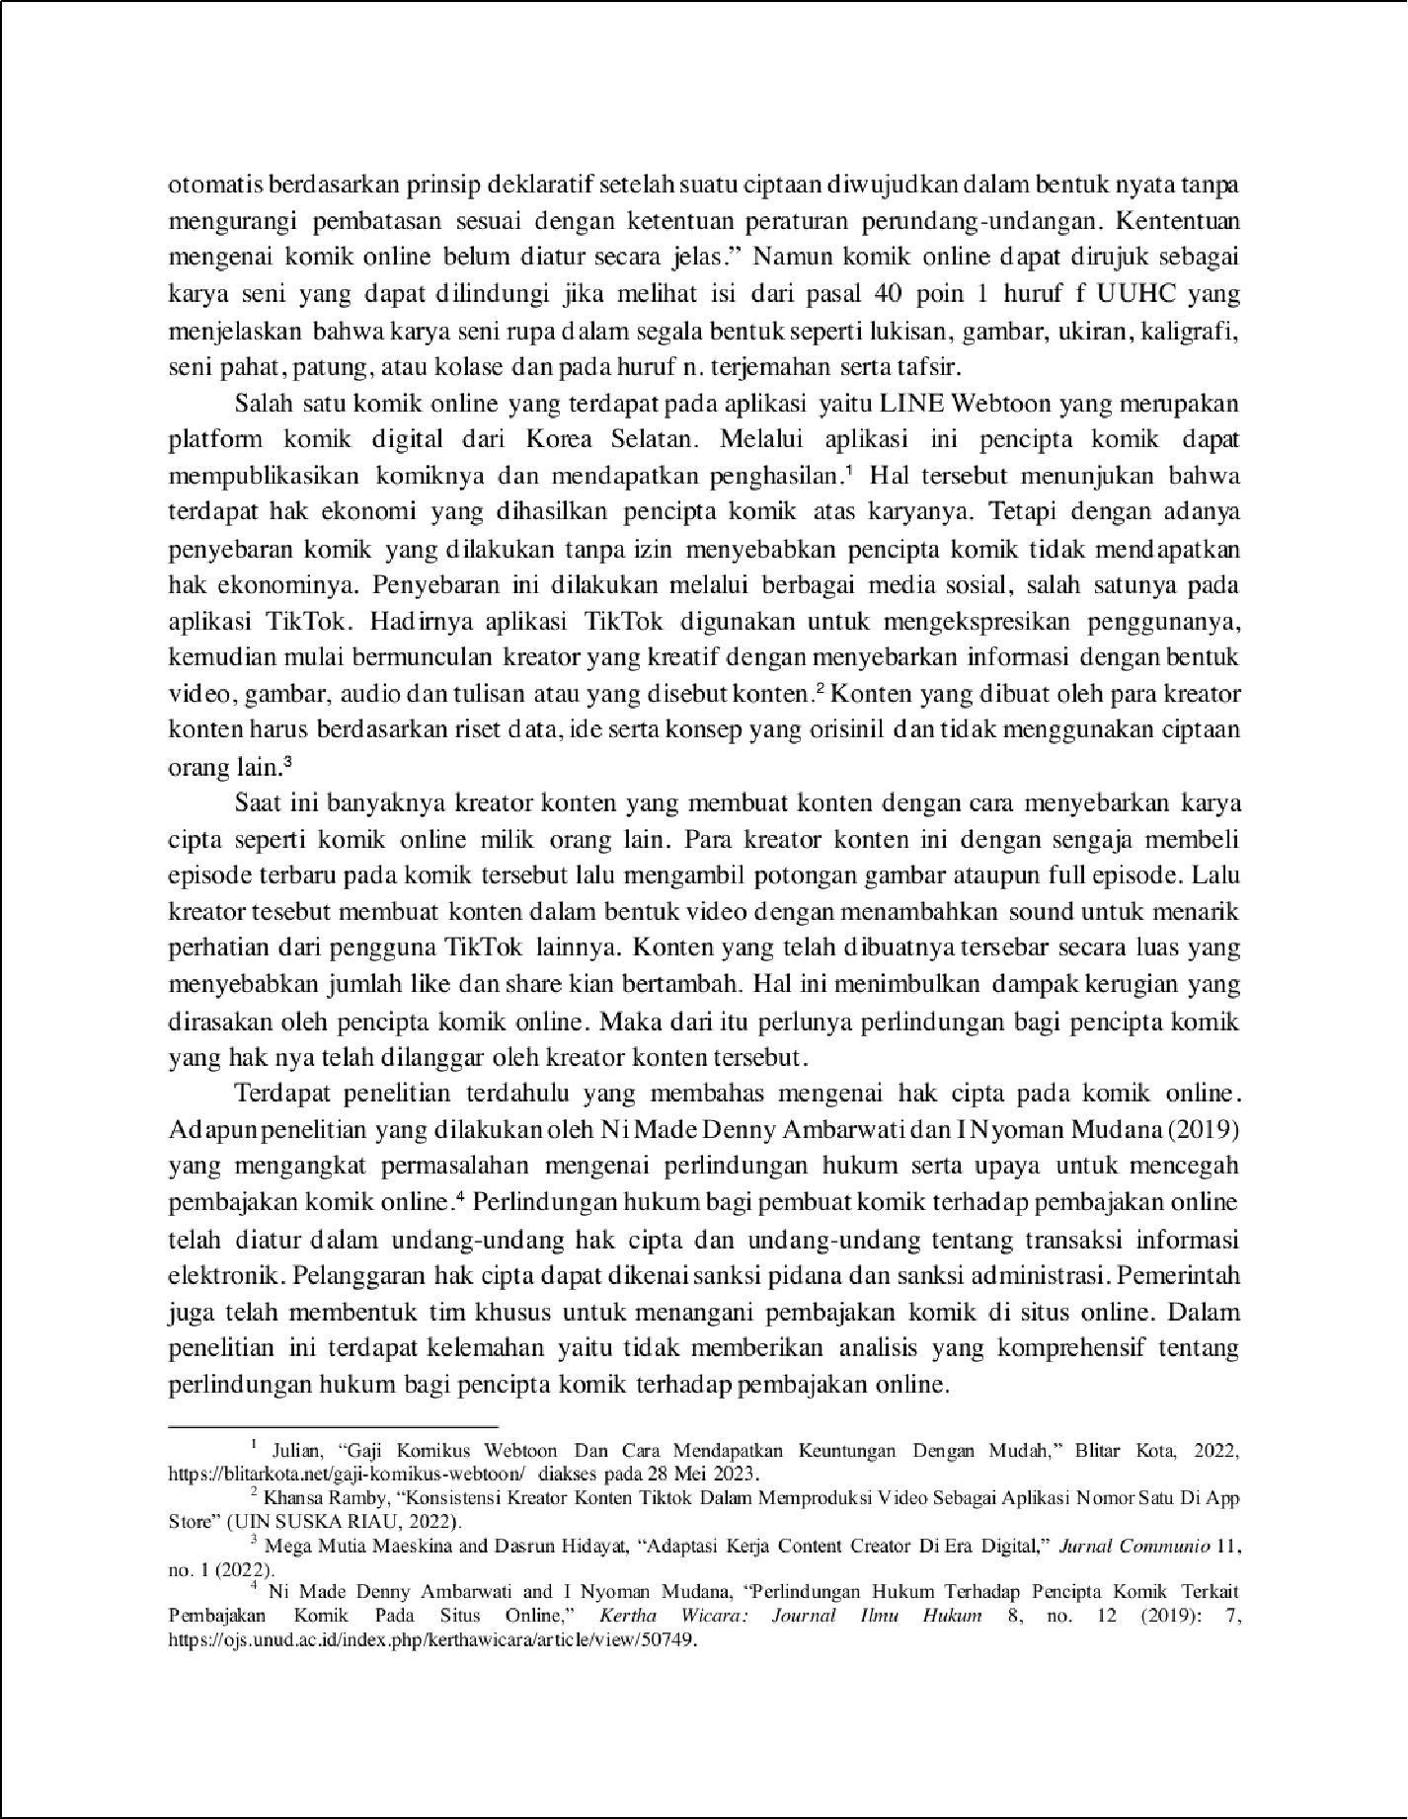

8

22

1

1

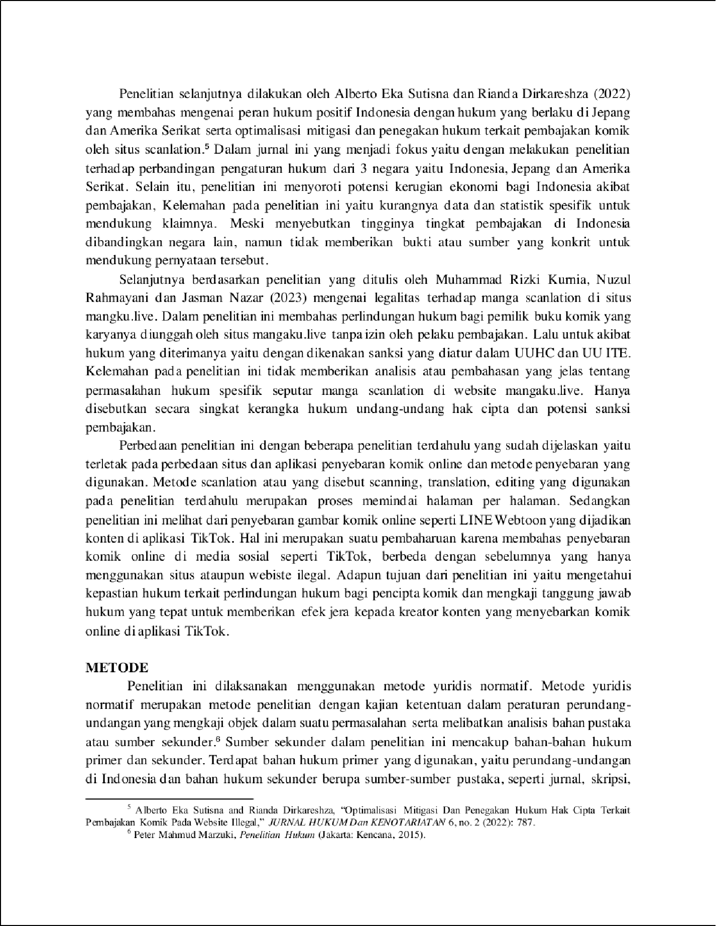

2

2

23

10

1

2

2

32

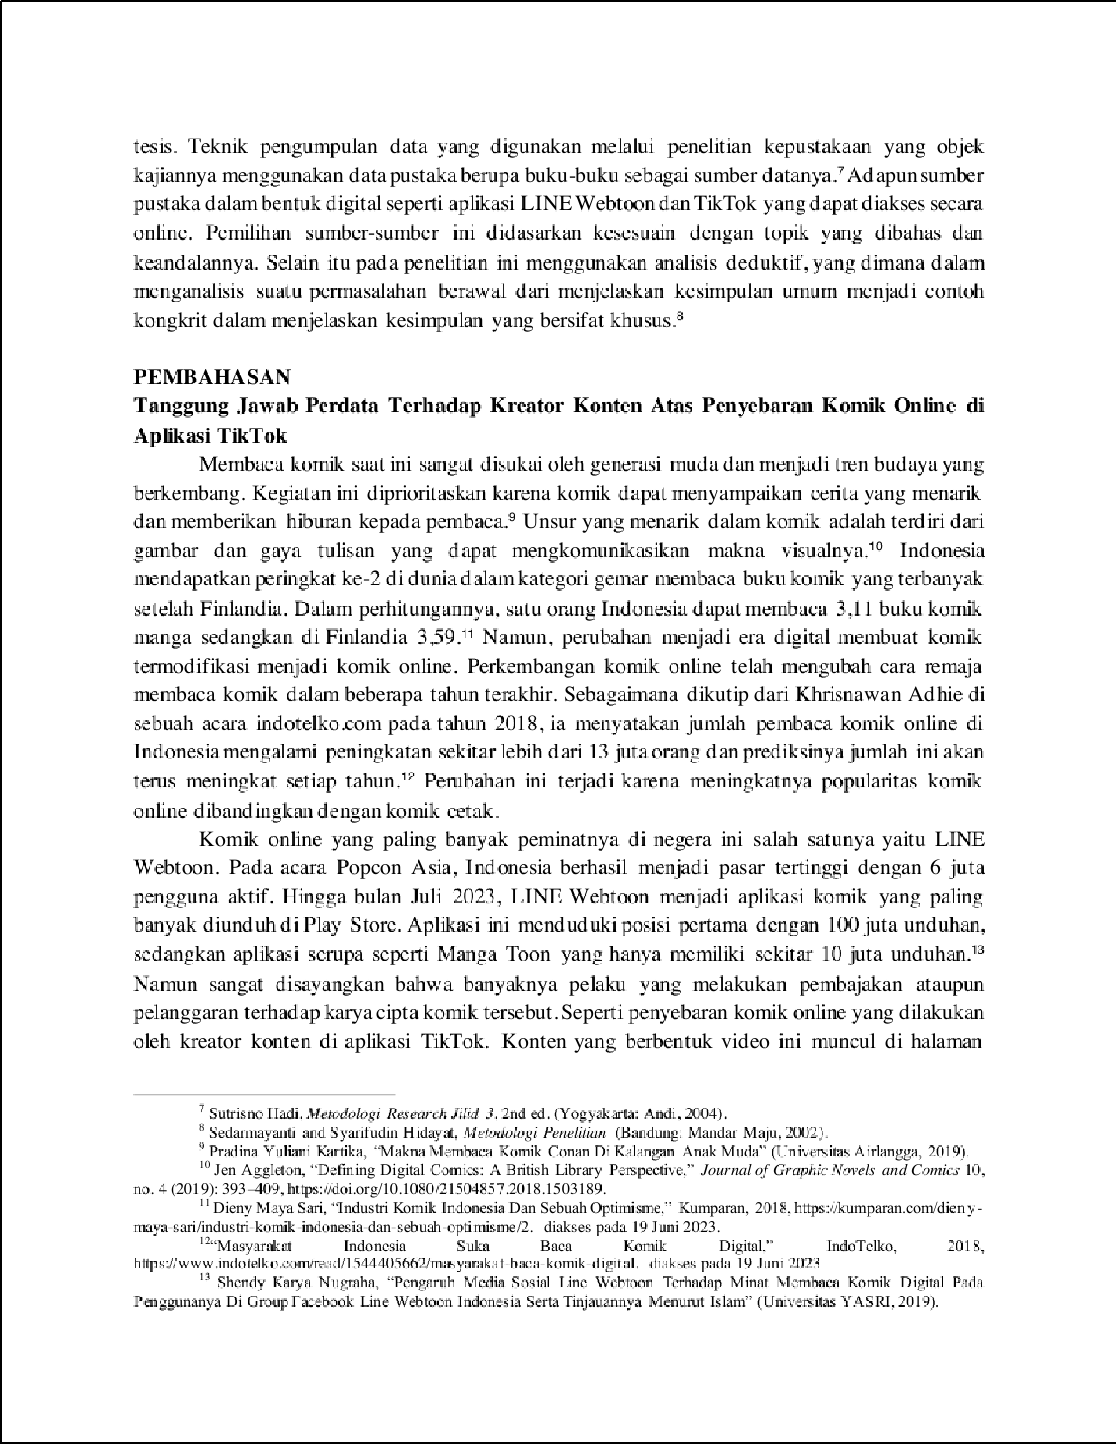

30

28

35

12

2

18

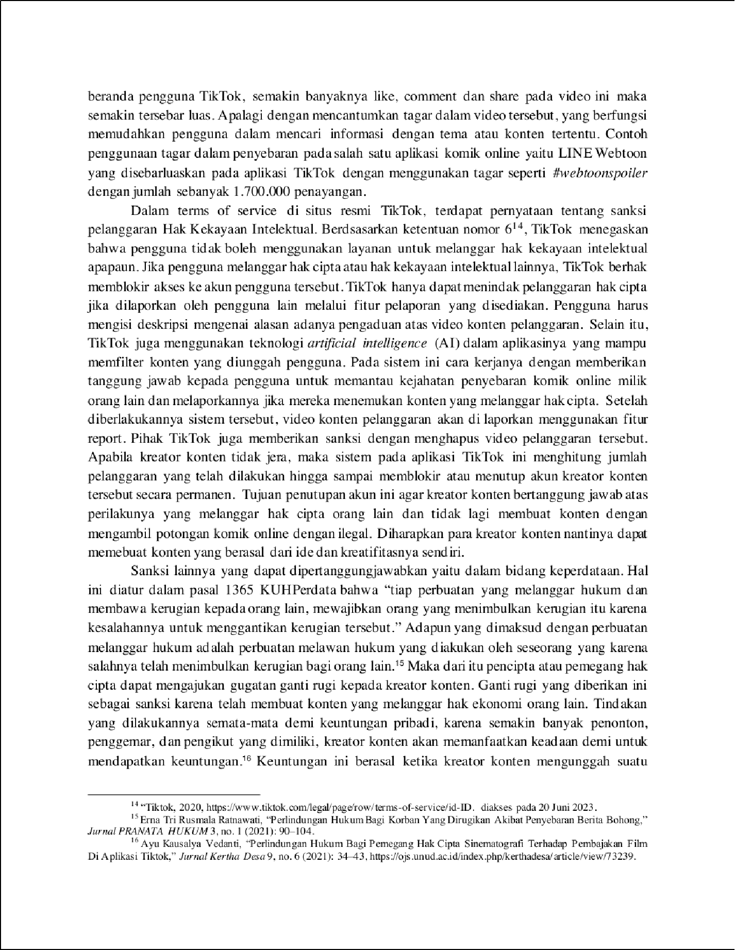

34

1

6

20

19

21

1 15

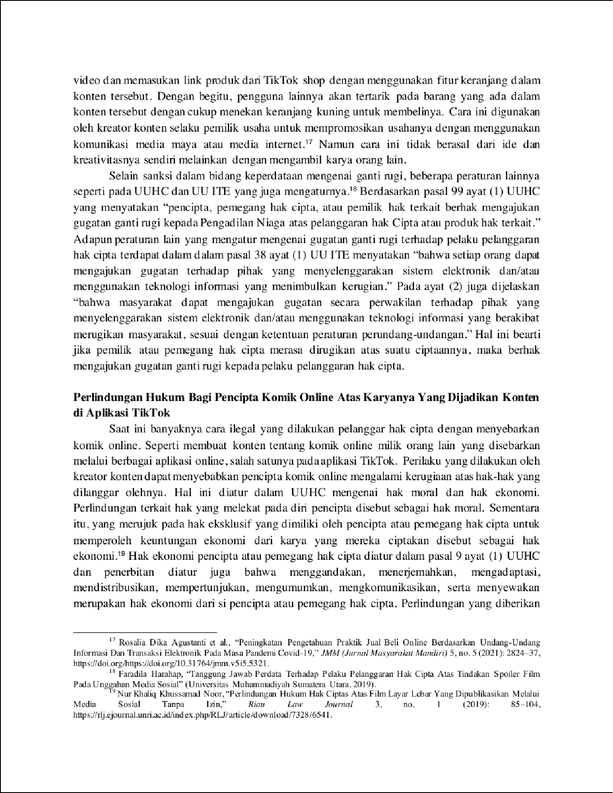

24

33

4

36

4

3

17

1

31

27

5

25

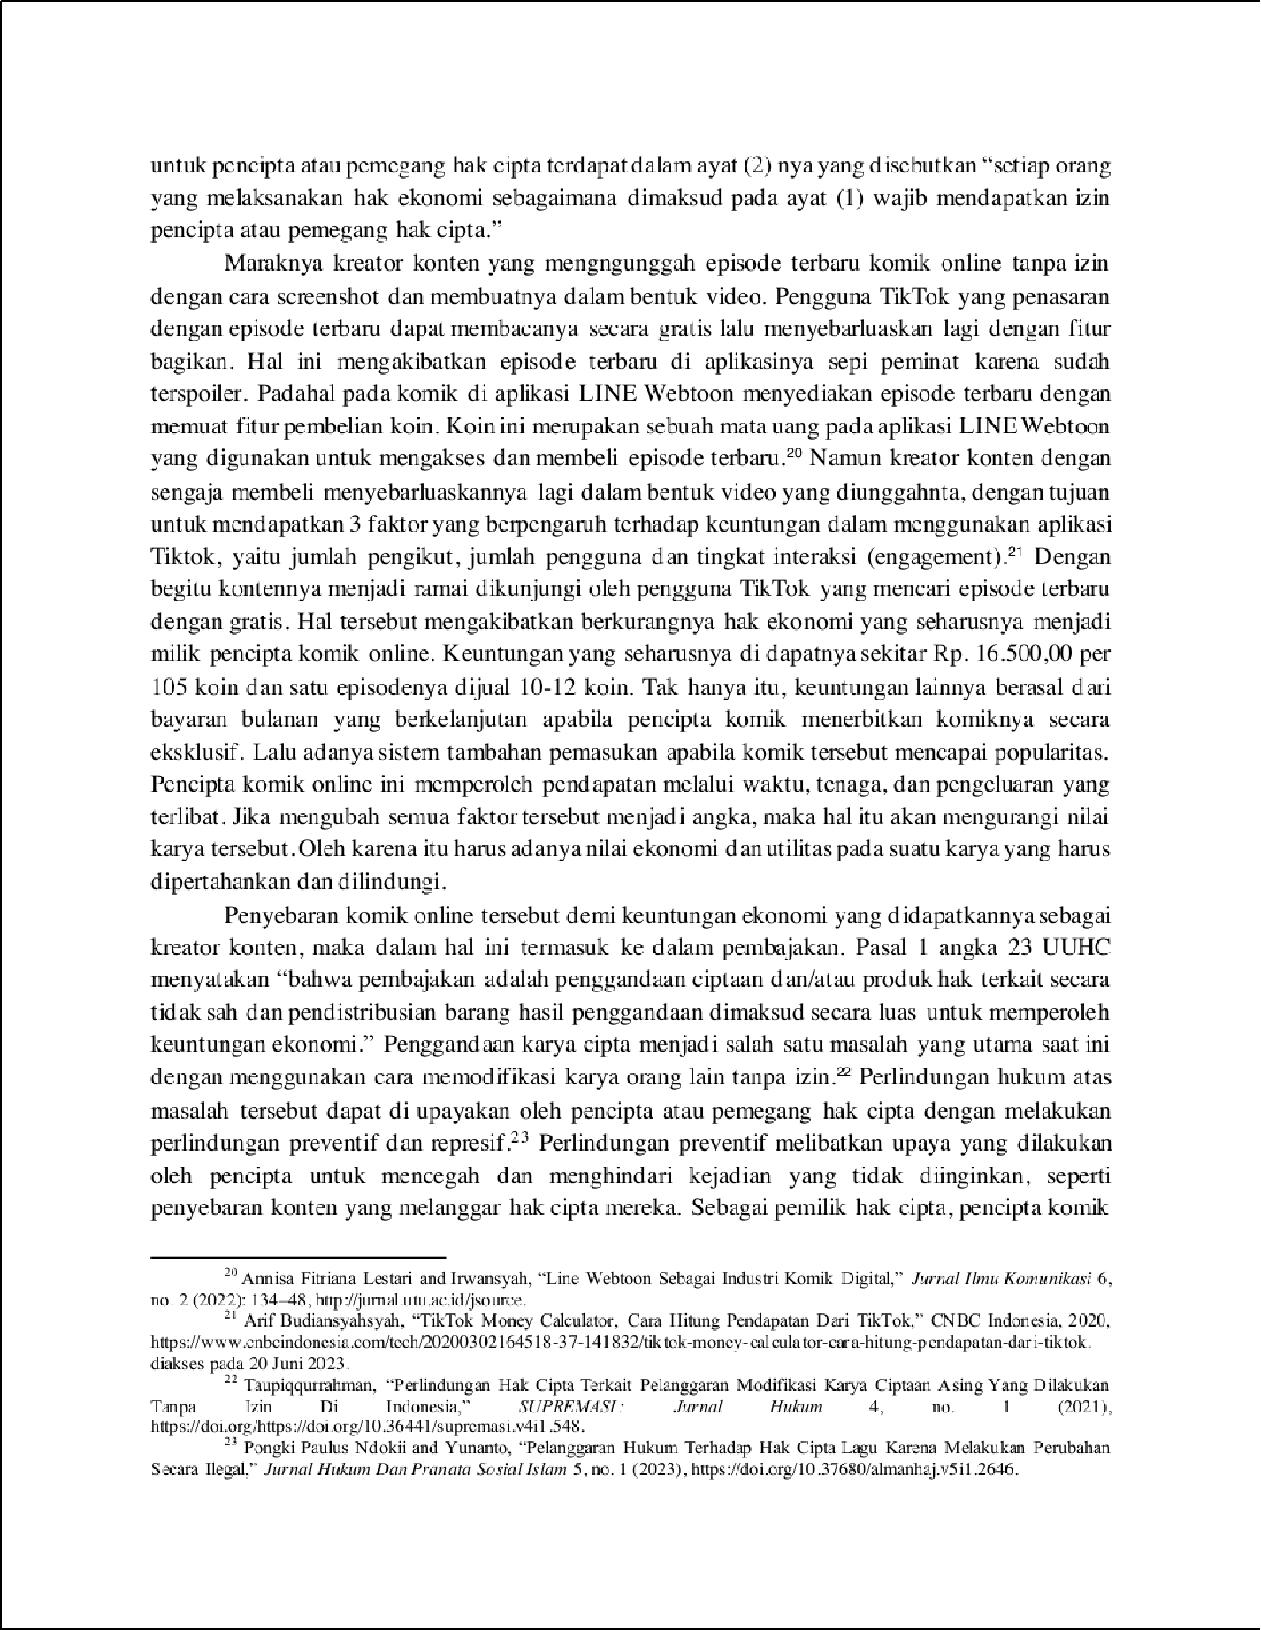

2

26

7

14

3

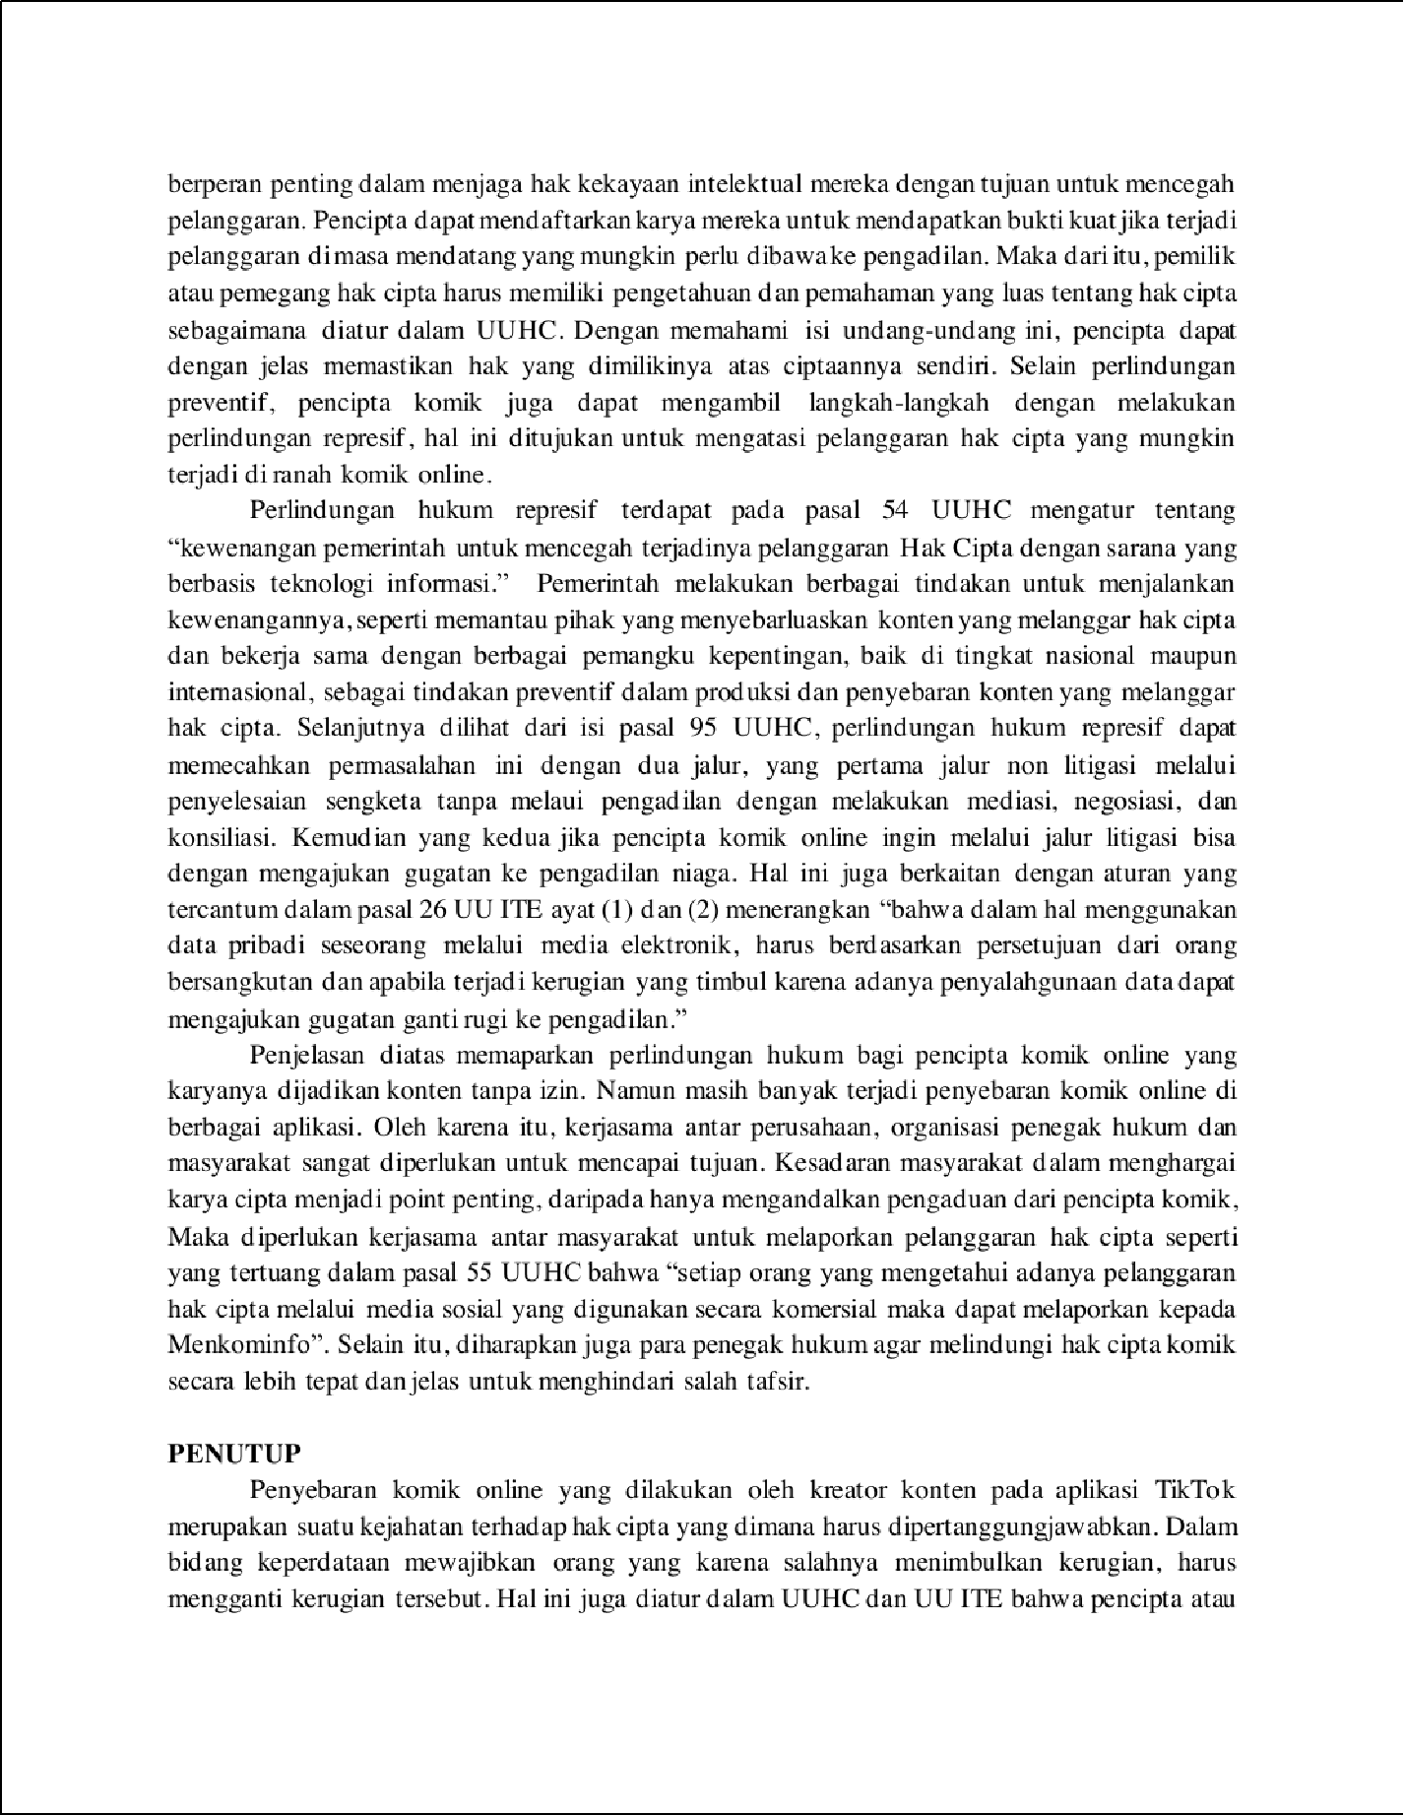

1

11

11

1

3

5

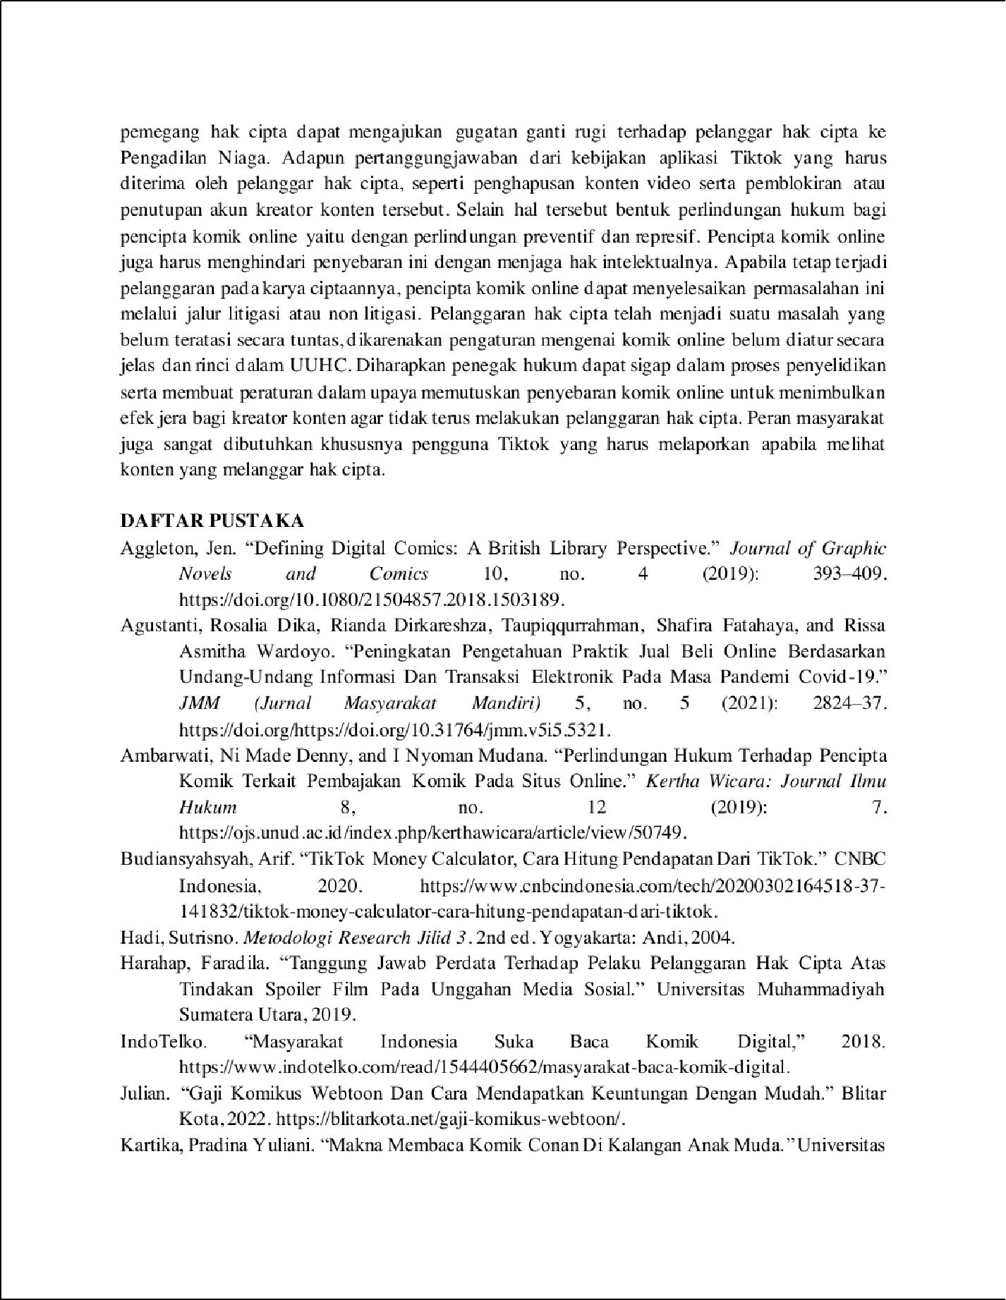

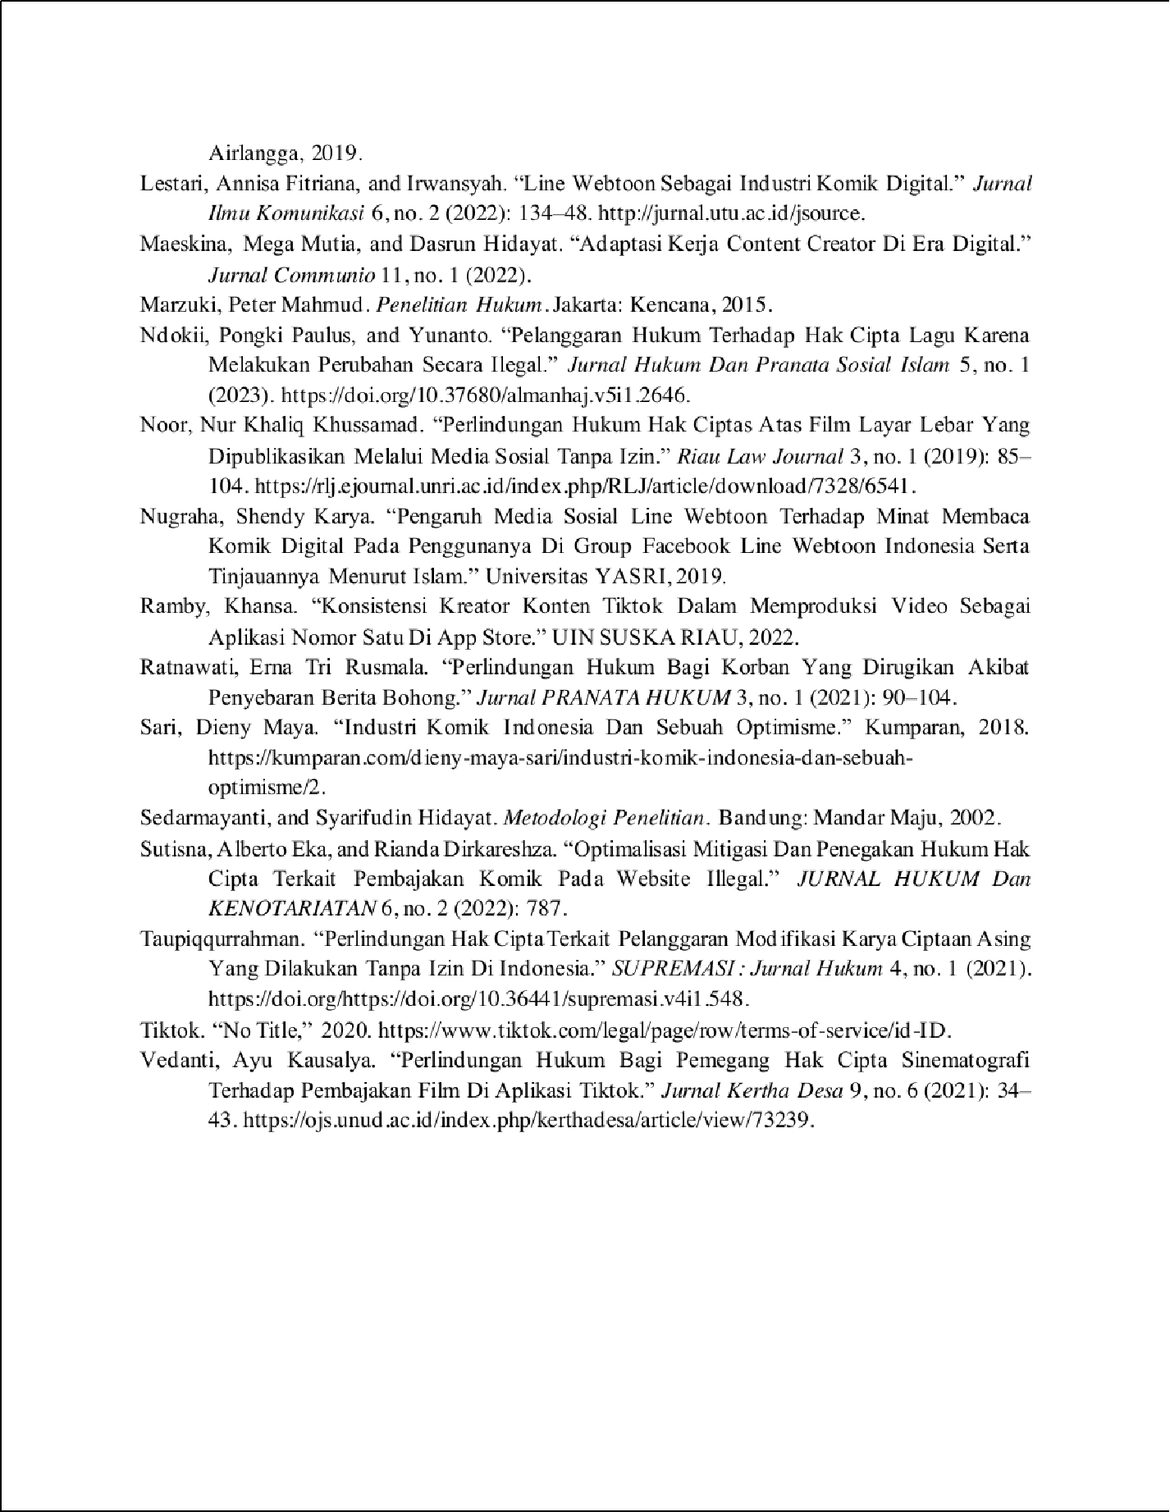

NASKAH JURNAL KARTIKA FH UPNVJ HAK CIPTA

14

ORIGINALITY REPORT

%

SIMILARITY INDEX

14%

INTERNET SOURCES

8%

PUBLICATIONS

8%

STUDENT PAPERS

PRIMARY SOURCES

ojs.unud.ac.id

1

Internet Source

riset.unisma.ac.id

2

Internet Source

Submitted to Sriwijaya University

3

Student Paper

repository.umsu.ac.id

4

Internet Source

Submitted to UIN Syarif Hidayatullah Jakarta

5

Student Paper

ejournal.widyamataram.ac.id

6

Internet Source

Submitted to UPN Veteran Jakarta

7

Student Paper

Submitted to Universitas Hang Tuah Surabaya

8

Student Paper

[www.researchgate.net](http://www.researchgate.net/)

9

Internet Source

2%

1%

1%

1%

1%

1%

<1%

<1%

<1%

10

11

12

13

14

15

16

17

18

19

20

21

journals.usm.ac.id

Internet Source

ejournal.insuriponorogo.ac.id

Internet Source

Submitted to Sveučilite u Zadru | NOVA LICENCA

Student Paper

Submitted to Universitas Diponegoro

Student Paper

journal.uib.ac.id

Internet Source

jurnal.uns.ac.id

Internet Source

eprints.walisongo.ac.id

Internet Source

etheses.uin-malang.ac.id

Internet Source

journal.isi.ac.id

Internet Source

e-journal.uajy.ac.id

Internet Source

e-jurnal.lppmunsera.org

Internet Source

journal.uinsgd.ac.id

<1%

<1%

<1%

<1%

<1%

<1%

<1%

<1%

<1%

<1%

<1%

22

23

24

25

26

27

28

29

30

31

Internet Source

123dok.com

Internet Source

es.scribd.com

Internet Source

journal.ummat.ac.id

Internet Source

repository.ub.ac.id

Internet Source

repository.unj.ac.id

Internet Source

[www.jbasic.org](http://www.jbasic.org/)

Internet Source

[www.scribd.com](http://www.scribd.com/)

Internet Source

Parningotan Malau. "Tinjauan Kitab Undang- Undang Hukum Pidana (KUHP) Baru 2023", AL-MANHAJ: Jurnal Hukum dan Pranata Sosial Islam, 2023

Publication

daftar.ekuitas.ac.id

Internet Source

repository.radenfatah.ac.id

Internet Source

<1%

<1%

<1%

<1%

<1%

<1%

<1%

<1%

<1%

<1%

<1%

32

33

34

35

36

repository.unej.ac.id

Internet Source

Habi Kusno. "PERLINDUNGAN HUKUM HAK CIPTA TERHADAP PENCIPTA LAGU YANG DIUNDUH MELALUI INTERNET", FIAT JUSTISIA, 2017

Publication

[www.tiktok.com](http://www.tiktok.com/)

Internet Source

repository.unair.ac.id

Internet Source

repository.upstegal.ac.id

Internet Source

<1%

<1%

<1%

<1%

<1%

Exclude quotes On Exclude bibliography On

Exclude matches Oﬀ

NASKAH JURNAL KARTIKA FH UPNVJ HAK CIPTA

GRADEMARK REPORT

FINAL GRADE

# /0

GENERAL COMMENTS

**Instructor**

PAGE 1

PAGE 2

PAGE 3

PAGE 4

PAGE 5

PAGE 6

PAGE 7

PAGE 8

PAGE 9

PAGE 10