LAMPIRAN 1

Gambar 4.1 Model CFA Konstruk Eksogen
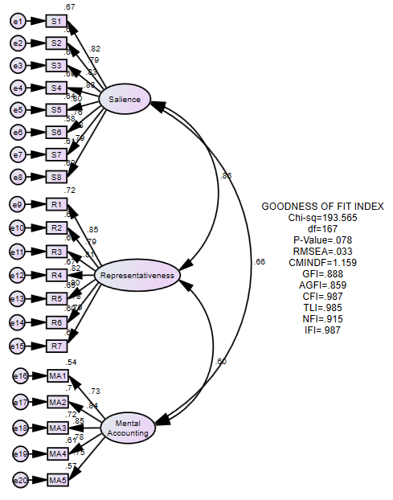
Tabel 4.8 Standardized Regression Weights: (Group number 1 - Default model)
 |  |  | Estimate
S8 | <--- | Salience | .790
S7 | <--- | Salience | .780
S6 | <--- | Salience | .762
S5 | <--- | Salience | .800
S4 | <--- | Salience | .833
S3 | <--- | Salience | .827
S2 | <--- | Salience | .785
S1 | <--- | Salience | .820
R6 | <--- | Representativeness | .777
R5 | <--- | Representativeness | .804
R4 | <--- | Representativeness | .821
R3 | <--- | Representativeness | .808
R2 | <--- | Representativeness | .786
MA4 | <--- | Mental_Accounting | .781
MA3 | <--- | Mental_Accounting | .850
MA2 | <--- | Mental_Accounting | .842
MA1 | <--- | Mental_Accounting | .732
MA5 | <--- | Mental_Accounting | .752
R7 | <--- | Representativeness | .791
R1 | <--- | Representativeness | .847
Sumber: Olah data Amos, 2019

LAMPIRAN 2
Gambar 4.2 Model CFA Konstruk Endogen
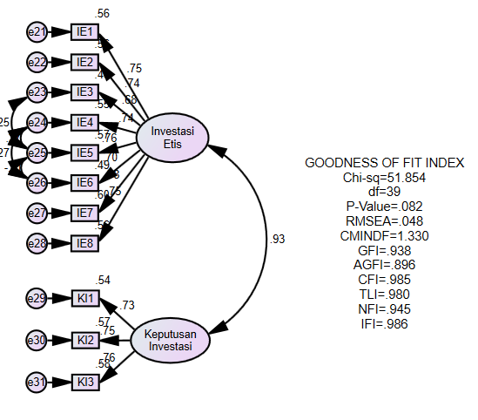

Tabel 4.9 Standardized Regression Weights: (Group number 1 - Default model)
 |  |  | Estimate
IE6 | <--- | Investasi_Etis | .699
IE5 | <--- | Investasi_Etis | .758
IE4 | <--- | Investasi_Etis | .740
IE3 | <--- | Investasi_Etis | .679
KI1 | <--- | Keputusan_Investasi | .735
KI2 | <--- | Keputusan_Investasi | .754
KI3 | <--- | Keputusan_Investasi | .764
IE8 | <--- | Investasi_Etis | .749
IE7 | <--- | Investasi_Etis | .776
IE2 | <--- | Investasi_Etis | .745
IE1 | <--- | Investasi_Etis | .749
Sumber: Output Amos 2019

LAMPIRAN 3
Tabel 4.10 Hasil Uji Normalitas Univariate dan Multivariate
Variable | min | max | skew | c.r. | kurtosis | c.r.
KI3 | 1.000 | 5.000 | -.269 | -1.321 | .232 | .570
KI2 | 1.000 | 5.000 | .017 | .085 | .038 | .094
KI1 | 1.000 | 5.000 | -.439 | -2.159 | -.023 | -.056
IE1 | 1.000 | 5.000 | -.128 | -.627 | .286 | .703
IE2 | 1.000 | 5.000 | -.198 | -.971 | -.314 | -.771
IE3 | 1.000 | 5.000 | -.141 | -.691 | -.380 | -.934
IE4 | 1.000 | 5.000 | -.326 | -1.602 | -.490 | -1.204
IE5 | 1.000 | 5.000 | -.197 | -.969 | -.278 | -.683
IE6 | 1.000 | 5.000 | -.177 | -.868 | .467 | 1.147
IE7 | 1.000 | 5.000 | -.272 | -1.336 | .280 | .687
IE8 | 1.000 | 5.000 | -.078 | -.383 | .142 | .350
MA1 | 2.000 | 5.000 | -.027 | -.133 | -.365 | -.896
MA2 | 2.000 | 5.000 | -.064 | -.313 | -.453 | -1.113
MA3 | 1.000 | 5.000 | -.405 | -1.992 | .045 | .111
MA4 | 1.000 | 5.000 | -.295 | -1.448 | -.375 | -.922
MA5 | 1.000 | 5.000 | -.337 | -1.657 | .089 | .219
R1 | 1.000 | 5.000 | -.247 | -1.216 | -.031 | -.076
R2 | 1.000 | 5.000 | -.026 | -.130 | -.278 | -.682
R3 | 1.000 | 5.000 | -.114 | -.558 | -.274 | -.673
R4 | 1.000 | 5.000 | -.194 | -.955 | .042 | .103
R5 | 1.000 | 5.000 | -.334 | -1.644 | .248 | .609
R6 | 1.000 | 5.000 | -.047 | -.231 | .113 | .278
R7 | 2.000 | 5.000 | .045 | .223 | -.456 | -1.120
S1 | 1.000 | 5.000 | -.230 | -1.130 | -.336 | -.827
S2 | 1.000 | 5.000 | -.233 | -1.147 | .354 | .869
S3 | 1.000 | 5.000 | -.393 | -1.931 | .151 | .372
S4 | 1.000 | 5.000 | -.300 | -1.476 | .383 | .942
S5 | 2.000 | 5.000 | -.110 | -.542 | -.433 | -1.063
S6 | 1.000 | 5.000 | .056 | .277 | -.046 | -.114
S7 | 1.000 | 5.000 | .057 | .278 | -.107 | -.264
S8 | 1.000 | 5.000 | -.186 | -.912 | .083 | .204
Multivariate |  |  |  |  | 14.961 | 1.991
Sumber: Output Amos 2019
LAMPIRAN 4

Tabel 4.11 Univariate Outliers
Observation number | Mahalanobis d-squared | p1 | p2
40 | 54.836 | .005 | .531
3 | 53.924 | .007 | .246
5 | 53.533 | .007 | .088
92 | 52.523 | .009 | .046
68 | 49.588 | .018 | .131
72 | 48.054 | .026 | .178
4 | 47.597 | .029 | .126
2 | 44.568 | .054 | .535
143 | 44.056 | .060 | .514
137 | 43.866 | .063 | .424
59 | 43.632 | .066 | .355
14 | 43.347 | .069 | .307
36 | 42.193 | .087 | .491
8 | 40.997 | .108 | .711
10 | 40.688 | .114 | .697
23 | 40.614 | .116 | .619
64 | 40.502 | .118 | .551
9 | 40.303 | .122 | .511
54 | 39.824 | .133 | .565
18 | 39.495 | .141 | .576
32 | 38.630 | .163 | .755
28 | 38.345 | .171 | .761
37 | 38.029 | .180 | .777
118 | 37.767 | .187 | .781
73 | 37.637 | .191 | .750
124 | 37.607 | .192 | .687
116 | 37.353 | .200 | .695
25 | 37.169 | .206 | .681
41 | 36.309 | .235 | .863
47 | 36.041 | .244 | .876
138 | 36.027 | .245 | .833
45 | 35.976 | .247 | .794
53 | 35.666 | .258 | .825
11 | 35.643 | .259 | .777
6 | 35.555 | .262 | .745
77 | 35.541 | .263 | .685
96 | 35.441 | .267 | .653
129 | 35.349 | .270 | .618
60 | 35.156 | .278 | .623
63 | 35.049 | .282 | .595
127 | 35.008 | .283 | .539
144 | 34.290 | .313 | .753
65 | 34.082 | .322 | .767
111 | 33.855 | .331 | .788
58 | 33.655 | .340 | .800
38 | 33.601 | .342 | .765
19 | 33.287 | .356 | .816
119 | 33.267 | .357 | .772
86 | 33.032 | .368 | .798
75 | 32.871 | .375 | .801
20 | 32.813 | .378 | .770
82 | 32.758 | .381 | .736
88 | 32.751 | .381 | .679
62 | 32.515 | .392 | .714
104 | 32.335 | .401 | .727
35 | 32.320 | .401 | .674
130 | 32.190 | .408 | .668
132 | 32.009 | .416 | .684
30 | 31.884 | .422 | .677
113 | 31.635 | .435 | .721
139 | 31.322 | .450 | .786
74 | 31.095 | .461 | .816
123 | 30.995 | .466 | .804
93 | 30.858 | .473 | .804
122 | 30.701 | .481 | .811
145 | 30.642 | .484 | .784
52 | 30.624 | .485 | .739
22 | 30.559 | .489 | .711
98 | 30.530 | .490 | .664
46 | 30.440 | .495 | .644
89 | 30.437 | .495 | .582
33 | 30.300 | .502 | .583
120 | 30.253 | .504 | .541
13 | 30.181 | .508 | .510
69 | 30.124 | .511 | .473
15 | 30.041 | .515 | .448
76 | 30.015 | .517 | .395
117 | 29.954 | .520 | .361
103 | 29.724 | .532 | .407
106 | 29.689 | .533 | .360
110 | 29.589 | .539 | .345
100 | 29.458 | .545 | .344
57 | 29.430 | .547 | .297
109 | 29.366 | .550 | .268
85 | 29.285 | .554 | .246
114 | 29.252 | .556 | .208
101 | 28.905 | .574 | .294
80 | 28.882 | .575 | .248
97 | 28.872 | .576 | .201
48 | 28.833 | .578 | .169
126 | 28.793 | .580 | .141
34 | 28.722 | .584 | .123
134 | 28.246 | .608 | .235
50 | 28.063 | .618 | .253
136 | 27.828 | .630 | .296
90 | 27.811 | .631 | .246
112 | 27.794 | .632 | .201
39 | 27.679 | .638 | .193
140 | 27.674 | .638 | .150
95 | 27.011 | .672 | .357
Sumber: Output Amos 2019

LAMPIRAN 5
Tabel 4.12 Hasil Uji Validitas Indikator dan Reliabilitas Konstruk Variabel Eksogen
No | Variabel | Indikator | Standard Loading (Loading Factor) | Standar Loading^2 | Measurement Error (1-Std Loading^2) | Construct Reliability | Variance Extracted
1 | Salience | S1 | 0.820 | 0.672 | 0.328 | 0.934 | 0.640
 |  | S2 | 0.785 | 0.616 | 0.384
 |  | S3 | 0.827 | 0.684 | 0.316
 |  | S4 | 0.833 | 0.694 | 0.306
 |  | S5 | 0.800 | 0.640 | 0.360
 |  | S6 | 0.762 | 0.581 | 0.419
 |  | S7 | 0.780 | 0.608 | 0.392
 |  | S8 | 0.790 | 0.624 | 0.376
 |  | Sigma | 6.397 | 5.120 | 2.880
 |  | Sigma^2 | 40.922
2 | Representativeness | R1 | 0.847 | 0.717 | 0.283 | 0.928 | 0.648
 |  | R2 | 0.786 | 0.618 | 0.382
 |  | R3 | 0.808 | 0.653 | 0.347
 |  | R4 | 0.821 | 0.674 | 0.326
 |  | R5 | 0.804 | 0.646 | 0.354
 |  | R6 | 0.777 | 0.604 | 0.396
 |  | R7 | 0.791 | 0.626 | 0.374
 |  | Sigma | 5.634 | 4.538 | 2.462
 |  | Sigma^2 | 31.742
3 | Mental Accounting | MA1 | 0.732 | 0.536 | 0.464 | 0.894 | 0.629
 |  | MA2 | 0.842 | 0.709 | 0.291
 |  | MA3 | 0.850 | 0.723 | 0.278
 |  | MA4 | 0.781 | 0.610 | 0.390
 |  | MA5 | 0.752 | 0.566 | 0.434
 |  | Sigma | 3.957 | 3.143 | 1.857
 |  | Sigma^2 | 15.658

Sumber: Data diolah peneliti, 2019

Tabel 4.13 Uji Validitas Indikator dan Reliabilitas Konstruk Variabel Endogen
No | Variabel | Indikator | Standard Loading (Loading Factor) | Standar Loading^2 | Measurement Error (1-Std Loading^2) | Construct Reliability | Variance Extracted
1 | Investasi Etis | IE1 | 0.749 | 0.561 | 0.439 | 0.905 | 0.544
 |  | IE2 | 0.745 | 0.555 | 0.445
 |  | IE3 | 0.679 | 0.461 | 0.539
 |  | IE4 | 0.740 | 0.548 | 0.452
 |  | IE5 | 0.758 | 0.575 | 0.425
 |  | IE6 | 0.699 | 0.489 | 0.511
 |  | IE7 | 0.776 | 0.602 | 0.398
 |  | IE8 | 0.749 | 0.561 | 0.439
 |  | Sigma | 5.895 | 4.351 | 3.649
 |  | Sigma^2 | 34.751
2 | Keputusan Investasi | KI1 | 0.75 | 0.540 | 0.460 | 0.795 | 0.564
 |  | KI2 | 0.754 | 0.569 | 0.431
 |  | KI3 | 0.764 | 0.584 | 0.416
 |  | Sigma | 2.253 | 1.692 | 1.308
 |  | Sigma^2 | 5.076
Sumber: Data diolah peneliti, 2019

